THE CENTRAL BANK

OF THE REPUBLIC OF ARMENIA

Approved under Board of the Central Bank Resolution No. 27A,

dated February 26, 2016

Inflation Report

Monetary Policy Program, Q1, 2016

⬅

Status Report on Implementation of the Monetary Policy Program, Q4, 2015

Table of Contents

1. Executive Summary........................................................................
2. Forecast, Forecast Changes and Risks ..........................................
2.1. External environment................................................................

2.2. Aggregate supply and aggregate demand .................................

2.3. Inflation forecasts and monetary policy directions in 3-year forecast horizon .............................................................................
3. Actual Developments in Q4, 2015 ....................................................

3.1. Inflation...........................................................................................

3.1.1. Actual inflation and fulfilment of the inflation target..................

3.1.2. Import prices and producer prices.............................................

3.1.3. Inflation and interest rate expectations ......................................

3.2. Aggregate supply and aggregate demand....................................

3.2.1. Aggregate supply .......................................................................

3.2.2. Aggregate demand ....................................................................

3.2.3. Labor market ............................................................................

3.2.4. Fiscal policy ...............................................................................

3.3. Money and financial market developments ................................

3.3.1. Financial market, money and credit ...........................................

3.3.2. Exchange rate.............................................................................

3.4. Balance of payments .....................................................................

3.4.1. Current account .........................................................................

3.4.2. Capital and financial account ...................................................

3.5. External environment....................................................................
4. Conclusion...........................................................................................

Starting from January 2006, the Central Bank of Armenia has moved to a fully-fledged inflation targeting strategy, which highlights the importance of communicating of the Bank to the general public by publishing, inter alia, quarterly inflation reports. First section of the inflation report includes next quarter’s monetary policy program that provides new forecasts of inflation and other macroeconomic indicators and main directions of the monetary policy in the forecast horizon. Second section includes status report on implementation of the monetary policy program of the previous quarter, which covers actual economic and monetary developments.
Publishing of inflation forecast and assumptions underlying it makes the monetary policy of the Bank more transparent, understandable and predictable, which considerably increases the public confidence in the Bank. The Bank believes that a clear and trusted monetary policy positively affects the anchoring of inflation expectations and maintaining financial stability in terms of cost reduction.
Starting from the second quarter of 2012, the Bank has been publishing forecasts of non-conditional inflation in a 3-year time horizon, in implementation of the inflation targeting strategy, whereby the monetary policy is steered to minimize any deviations of potential inflation from a 4 % target.
Projections in this report are based on the factual information available by February 16, 2016, i.e. the day on which the refinancing rate was set, the results of a survey conducted by the Bank and the judgment made pursuant to the information on future macroeconomic developments​​.
All inflation reports which have been published to date are available on the Bank’s website which also contains monetary policy-related publications.

1. Executive Summary

In the time of unfavorable economic developments in the main partner countries on the Armenian economy and inexorable influence of deflationary trends in international markets of commodities and food products, the economic growth in 2016 will remain weak. The 12-month inflation rate, although low at the beginning of the year, will tend to expand. Starting from 2017, the economic growth will accelerate to gradually approach the long-term equilibrium and inflation will continue to expand, stabilizing around the 4% target.
In 2016, the economic growth will remain sluggish, whereas the 12-month inflation rate, although low at the beginning of the year, will tend to expand.
Starting from 2017, the economic growth will accelerate to gradually approach the long-term equilibrium and inflation will continue to expand, stabilizing around the 4% target.
In 2015 private consumption and private investment reduced (estimated to be around 8% each) due to noticeable reduction in real disposable household income because of shrinkage in money transfers from Russia, an overall low level of business activity and slowed down lending growth rates. The negative impact of the reduction on economic growth was largely mitigated as the Republic of Armenia Government (hereinafter “the Government”) continued implementing expansionary fiscal policy while the Central Bank of Armenia (hereinafter “the CBA”) eased monetary conditions considerably. Low domestic demand prompted the import of goods and services to decrease by around 7.0% in real terms in 2015, which went along with 14.0% y/y real growth of the export of goods and services, leading to improved real net exports. As a result of these developments, the economic activity indicator in 2015 reached y/y 3.1% mainly due to increased output volumes in agriculture and mining sectors, in which case the economic growth is estimated in the range of 3.1-3.3% y/y.
In 2015 the economic growth is estimated in the range of 3.1-3.3%.
According to short-term forecasts of the CBA, the external sector will further see a slow pace of economic growth and deflationary environment. Fresh forecasts of decline in the Russian economy and the ruble devaluation are signaling that the dollar value of remittances of individuals would decrease even more (9.0-12.0%) during the year compared to the previous prediction, which will contribute to the low level of domestic demand, hence the shrinking of private consumption. The impact of fiscal policy on domestic demand (calculated over the previous year) is estimated 1.4 contractionary for the year, although the deficit-to-GDP ratio is higher from the past 5-year average, standing at 3.5% against 2.4%. In this case, private consumption will fall by 1.3%, while private investment will remain at the 2015 level. Driven by weak demand, the real import of goods and services will continue to decline by 6.0-8.0% in 2016 while the real growth of export of goods and services is forecast within 2.0-4.0% owing to expected moderate growth in industry and agriculture sectors. In view of these developments, the 2016 economic growth is estimated in the range of 1.5-2.6%.
Starting from 2017, the economic growth rates will speed up, carrying the influence of effective implementation of the Government program steered to export and investment promotion, gradual improvement in the external economic environment and structural reforms. Driven by these developments, it is expected that economic growth at the end of the forecast horizon will be within 3.0-4.5%.
In 2016 the economic growth is projected in the range of 1.5-2.6%.
At the end of forecast horizon, the economic growth will be within 3.0-4.5%.
Thus, in the forecast horizon, on the back of stabilizing private demand and contractionary effect of the fiscal policy, the impact of aggregate demand on domestic prices will be somewhat deflationary and is expected to phase out at the end of horizon.
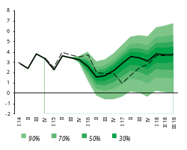
In the course of actual developments in 2015, the 12-month inflation rate fluctuated mainly within the confidence band, and it only stepped below the band at the end of the year, as a result of sharper falling. The year ended with an inflation indicator of -0.1%, which was determined by persistently low domestic and external demand, a large supply of agricultural products, as well as the fact that falling prices in external sector during 2015 had already partly reflected the domestic price reduction at the end of the year. In this situation, the CBA kept on easing monetary conditions in November-December by reducing the refinancing rate by 1.5 pp to 8.75% later the year. It was estimated that inflationary risks arisen from the previous year-end had been largely overcome, and abruptly eased monetary conditions made it possible to return to the normal situation that existed before November of 2014 (see details in section “3.1.1 Actual inflation and fulfillment of the inflation target”).
Real GDP Cumulative Growth Projection Probability Distribution Chart for a 3-year horizon
November 2015 projection
Current projection
A low deflationary environment will be maintained over the first half of 2016 as significant inflationary pressures from the domestic economy and external sector in the short run are not expected. Note that the inflationary effect from the change in the excise duty scheduled for May 2016 has been considered in inflation forecasts. The CBA, therefore, estimates that at the yearend the 12-month inflation rate will be at the lower bound of the confidence band; in the upcoming months, influenced by expansionary monetary policy implementation, it will expand gradually to approach and stabilize around the target in the forecast horizon.
Year 2015 ended with the 12-month inflation inficator amounting to -0.1%.
The CBA continued easing monetary conditions considerably in November-December by reducing the refinancing rate by 1.5 pp to 8.75% at the end of the year.
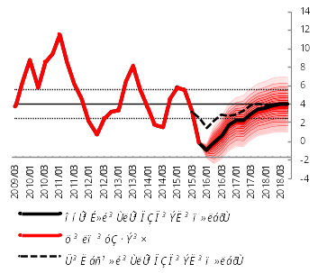
The CBA believes that further easing of monetary conditions in the first quarter of 2016 is relevant in such a low inflationary environment. This, coupled with loosened monetary conditions early in the year, will lead to the expanding of the aggregate demand and fulfillment of the inflation target in the forecast horizon. Moreover, gradual loosening of monetary conditions is important on the premise of relatively high inflation expectations and the risk to downside price rigidity and increasing dollarization. That said, in the time of a low inflationary environment and the lack of notable inflationary risks, the CBA refrains from more robust loosening of monetary conditions and rapid recovery of the 12-month inflation rate, taking into account still relatively high inflation expectations and the consideration that low inflation would somewhat cushion the decline in domestic demand, contribute to maintaining the purchasing power of incomes and restore the external competitiveness, which was damaged as a result of significant depreciation of partner countries’ currencies. In addition, reducing and anchoring inflation expectations are only possible through a low inflation.
Inflation (12-month) Forecast Probability Distribution Chart for a 3-year horizon

A weak deflationary environment will be persisting in the first quarter of 2016, and the CBA finds it appropriate to keep on easing the monetary conditions.
Reducing and anchoring inflation expectations are only possible through a low inflation.
Risks to inflation deviating from the projected value are estimated to be downside in the short run and balanced in the medium run. The downside risks are mainly attributable to the falling prices of commodities and food products in international markets and a spillover of greater impact of such price reduction on domestic prices as well as to the developments in prices of agricultural products. In the medium-term perspective, the risks deriving from domestic and external sectors are mostly persisting relative to the previous forecast. In particular, the external sector risks are related to the global economic decline and drop in international prices of commodities and food products driven by capital outflows from developing countries to the U.S.A., higher volatilities of currencies in developing countries and a sharp slowdown in Chinese economic growth. Risks deriving from the domestic sector are mostly associated with the developments in agriculture, a sector greatly depending on weather conditions, the pace at which domestic demand and private investments will recover, as well as Government-led promotion programs. If the aforementioned risks materialize, the CBA will react accordingly by maintaining the inflation target in the medium run.

2. Forecast, Forecast Changes and Risks

2.1. External environment

In 2016 trends of slow economic growth will continue to be observable in the global economy and main partner countries to Armenia. The economies of developing countries will grow somewhat faster, whereas a slow pace of growth is expected to persist in developed countries.
In 2016 economic growth will further trend slow in the global economy and main partner countries to Armenia.
In external markets, deflationary patterns will be persisting over 2016 due to a weak global demand and excess supply in individual commodity markets.
In 2016 deflationary patterns will prevail in international markets of basic commodities.
Economic growth in the U.S.A. in 2016 is estimated at around 2.4% (relative to the same growth estimation of the previous year), and it will be around 2.3% in the medium term. With the dollar gaining in value and the inflation environment remaining low, the U.S. Federal Reserve System will carry out a low interest rates policy until mid-2016, after which there would be a smooth rise in interest rates.
Economic growth in Eurozone in 2016 is predicted to slow down to some extent: it will average 1.2% against 1.5% growth recorded in the previous year. In the medium term, however, the growth rates will speed up to nearly 1.7%. The growth will be fostered largely by low commodity prices and the program of asset purchases by the European Central Bank. Inflation is still below its target level and may only come up to it at the end of the forecast horizon. With the aim to regulate inflation, the ECB will continue implementing an expansionary monetary policy and will carry on with the quantitative easing program up until mid-2017.
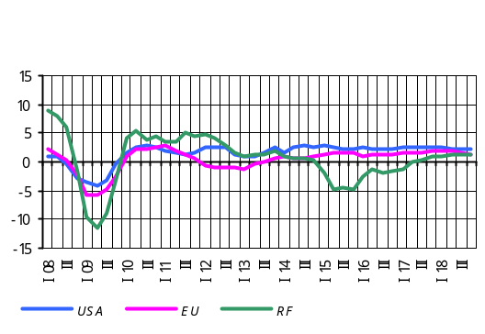In 2016 economic decline in Russia will continue; it will average 1.8% compared to the previous year’s decline of 4.0%. The economy will return to positive growth only in the middle of 2017 and the growth indicator is predicted to reach 1.4% at the end of the forecast horizon. Low oil prices remain a key factor that determines weak economic activity. This will keep the Russian ruble depreciated and the inflation environment elevated. However, the inflation rate may trend downward in the medium-run perspective owing to keeping the policy rates at the higher level. The inflation rate is predicted to approach its 4% target at the end of the forecast horizon only.
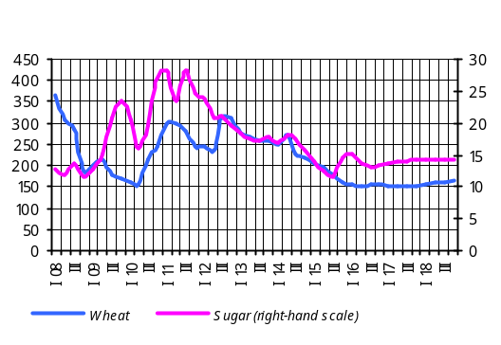According to the IMF January 2016 report “Global Economic Outlook”, world economic growth in 2015 was 3.1% and is predicted to reach 3.4% in 2016, which was revised 0.2 pp downside compared to the previous publication of the report in October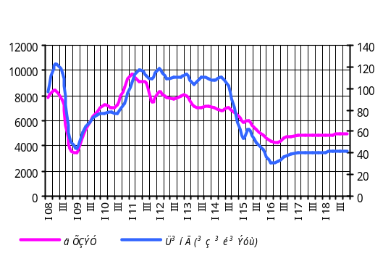.
With the global economy still on a slow-growth track and industrial output increasing, deflationary trends in world commodity and food product markets will remain until mid-2016, and only the latter part of the year will see signs of stabilization on the back of somehow rebounding global demand. It should be noted, however, that prices are expected to keep low up until the end of the forecast horizon.
Risks to the developments in global economy are much the same compared to the previous forecast. Positive risks related to persistently low prices in commodity and food product markets will continue pushing global demand up. Risks to a sharp decline in Chinese economy remain, too. This can lead to further contraction in global demand, which in turn will pose risks to the falling of international prices of commodities and food products. Risks associated with the further appreciation of the US dollar will persist, which could lead to capital outflows from developing countries.

Box 1

Developments in commodities markets
in the forecast horizon

The January 2016 report of the oil market published by the OPEC predicts that the global oil demand will grow in 2016 by 1.26 million b/d and consumption will reach 94.17 million b/d. The report also foresees that oil production outside OPEC in 2016 will reduce by 0.66 million b/d to 56.21 million b/d on average. Oil production by OPEC in 2016 will go up by 0.17 million b/d against the previous year’s relevant growth figure of 0.15. In the medium-term perspective, however, the oil prices are predicted to keep low in the light of still a large volume of supply andrelatively weak demand in the oil market.
A deflationary environment will further be seen in world metals markets owing to large-scale production volumes of metal and continued slowdown of the Chinese economy.
According to the January estimates of the U.S. Department of Agriculture, in the 2015/2016 marketing year some 735.4 million tons of wheat crops is expected (1.2 million tons more than in the previous marketing year). The world wheat stock is an estimated 232.04 million tons for the 2015/2016 marketing year. The wheat supply having increased that much will determine persisting deflationary patterns in the short run.
According to U.S. Department of Agriculture estimates, world rice production in the 2015/2016 marketing year will be 470.1 million tons, and world rice stocks will reach 89.7 million tons, reducing by 14.2 million tons compared to the previous year. Nevertheless, the prices of rice will keep low in the short-term in response to large volumes of supply.
World sugar prices are predicted to stop going up at the beginning of 2016 in consideration of delayed sugarcane harvest due to bad weather in late 2015 in Brazil, the world’s leading manufacturer and exporter of sugar. Some drop in sugar prices in the short-term is anticipated, however.

2.2. Aggregate supply and aggregate demand

Aggregate supply
The CBA revised its economic growth forecasts for 2015 slightly downside as the National Statistics Service of Armenia had the first semester’s economic growth indicator adjusted from 4.0% to 3.6%. As a result, the 2015 economic growth is projected in the range of 3.1-3.3%. Note that with the domestic demand diminishing, the economic growth in 2015 was underpinned by net exports which have grown thanks to structural reforms implemented in recent years, favorable developments in agricultural sector as well as Armenian dram’s depreciation against the U.S. dollar at the end of 2014.
Economic growth for 2015 is an estimated 3.1-3.3%.
The deterioration in the Russian economy and the ruble’s depreciation at the end of 2015 and early in 2016 lead to further shrinking in private money transfers , which in turn negatively affected the private spending in Armenia in 2016.. A contracting effect of remittances of individuals on the domestic demand will be mitigated by the influence of expansionary monetary policy carried out in 2015-2016 and an expected low inflationary environment in the economy. Under these circumstances, the domestic demand is expected to decline by 1.6%, which is significantly smaller than the 6.0% reduction in 2015.
Also, given the anticipated weak recovery of the economies in the partner countries in 2016, a low level of commodity prices, and highly saturated mining industry, the economic growth of the sector in 2016 is estimated at 1.5-2.6% (almost coincides with the prediction of the previous quarter).
Economic growth for 2016 is an estimated 1.5-2.6%.
Anticipated rebounding of the domestic demand, effective implementation of export and investment promotion policy of the Government, improving external economic environment and structural reforms are among key factors that will accelerate the economic growth, starting from 2017. Based on the above mentioned developments, it is expected that economic growth will speed up and be in the range of 3.0-4.5%, at the end of the forecast horizon, which will further be driven greatly by the tradable sector.
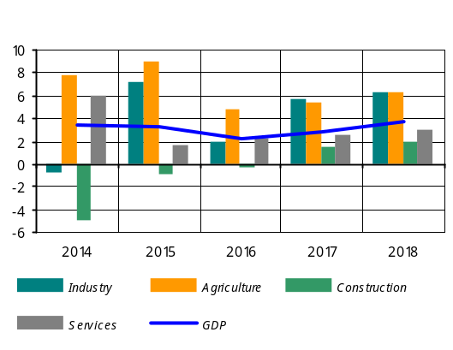 Given reduced long-term economic growth equilibriums amid growing uncertainties over further economic developments in partner countries to Armenia, anticipated slowing of foreign capital investment, and weak investment activity persisting in the domestic economy, Armenia’s long-term economic growth equilibrium is estimated within 4-5%. It should be noted, however, that estimated long-term GDP growth rate may decelerate if the structural reforms proceed slowly and investment in tradable sector grows unhurriedly.
For Industry, the forecasts were revised downside, mainly due to expected low prices of ore and minerals in world markets. As a result, in 2016 the value added in industry is forecast to grow within 1.3-2.1%, which is well below the average post-crisis growth in there. The slow growth in the sector will be determined by restrictions to extra growth opportunities due to a highly saturated mining industry reported in 2015, falling prices of ore and minerals, and because conditions for exporting goods from the domestic processing industry to the markets of the Russian Federation remain unfavorable.
In the forecast horizon, the industry growth will stabilize within 5.5-6.5%. This will be underpinned by implementing a handful of investment projects in the private sector, including the Amulsar mine operation, broadening export capacities in the context of export-promotion policy of the Government, identifying new export markets and embarking on product development.
For Construction, the 2016 forecasts of value added did not change much. In the enviornment of low investment activity in non-tradable sector of the economy and reduction in remittances from Russia, there is anticipation that volumes of construction funded by organizations and households may shrink. It should be noted, however, that relatively high investment activity in the tradable sector of the economy and improved lending conditions will cushion the above negative effects on the construction sector. As a result, the change in value added in construction in 2016 is expected from -0.8 to 0.2%.
In the forecast horizon, the growth is expected to stabilize within 1.5-2.0% as the supply and demand imbalance in the construction sector phases out. The growth will be fostered primarily by large construction projects designed for infrastructure improvement and investment projects in the private sector.
For Services, the 2016 forecasts of value added did not change notably (1.8-2.4%), with the growth of value added still lower than the average growth recorded in recent years. Expected slow growth rates in services are attributable to still a weak domestic demand observable in 2016, which may again result in contracting of trade albeit at smaller volumes compared to 2015. In the face of shrinkage in trade and other trade-related services, a moderate growth in 2016 can be anticipated as the sphere of non-commercial types of services is expected to grow significantly.
In the forecast horizon, growth in services is predicted to speed up and stabilize within 2.5-3.5% in expectation of gradual recovery of domestic demand and tourism growth.
For Agriculture, the forecasts of value added were revised slightly upside against previous forecasts. The revision was done based upon a more-than-expected growth in animal breeding in the fourth quarter of 2015 and increased export capacities which can be noticeable in the subsector. As a result, the real growth of value added in 2016 will be in the range of 4.2-5.0%.
In the forecast horizon, the growth in agriculture will accelerate and stabilize within 5.5-6.5%. Relatively high growth rates in the medium run will be possible to maintain by using more house farming and refrigerator facilities, arable lands, crops and cattle, and engaging extra means of transportation for exports, as a result of complex measures which the Government has consistently taken on in recent years.
In the forecast horizon, risks to the economic growth are dual-sided yet risks to downside growth outweigh. The risks to the economic growth are associated with uncertainties in global and domestic economic environments.
Among upside risks, most prominent are the expansion and use of export potential in certain sectors of the economy amid gradual recovery of global economy and growing competitiveness of Armenia, as well as identifying new export markets.
Downside risks include a possible contraction of agricultural output in 2016, which is attributable to saturation in the sector as a result of a record amount of harvest in 2015 and, therefore, less likelihood of a surplus growth relative to 2015.Lower than expected export growth rates compared to the baseline scenario contribute to the downside risks, the latter can be realized due to export sectror obstacles present in the Russian markets, declining mineral prices and finally due to the lower pace of economic reforms in Armenia.:
Real GDP Growth (Cumulative) Projection
Probability Distribution
Period | 30% probability interval |  | 90% probability interval
Period | Minimum | Maximum | Minimum | Maximum
January-December 2015 / January-December 2014 | 3.1% | 3.3% | 2.9% | 3.6%
January-December 2016 / January-December 2015 | 1.5% | 2.6% | -0.7% | 3.8%
January-December 2017 / January-December 2016 | 2.3% | 3.7% | -0.4% | 5.5%
January-December 2018 / January-December 2017 | 3.0% | 4.5% | 0.0% | 6.8%

Labor market: The 2016-2018 forecasts of average nominal wage were revised slightly downside in anticipation of a small rise in wages in the public sector in 2016 as well as a lower level of inflation projected for the year. Thus, average nominal wage is predicted to grow by 3.6% in 2016, by 5.0% in 2017 and by nearly 6.0% in 2018.
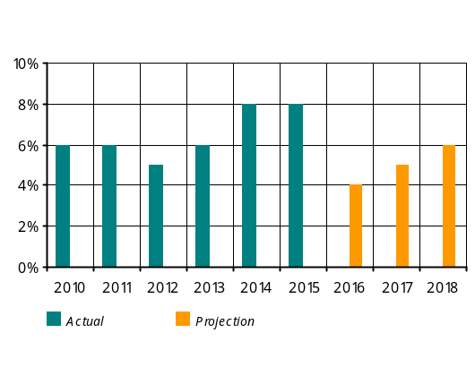The impact of wage increases in the public sector from July of 2014 has abolished since the second half of 2015, while the salary of those employed in certain areas of public sector have reduced since October. The above trend in the public sector will persist over 2016 too, yet a moderate growth of wages in the sector will be likely. Note that the minimum wage threshold has risen to AMD 55,000 since July of 2015. Considering that the minimum wage threshold will not increase in 2016 and the year will see a moderate economic growth, an average wage growth of 3.6% can be expected during 2016.
On the premise of projected economic growth, fulfillment of the inflation target and the ongoing Government policy to gear up to a minimum wage increase starting from 2017, the average annual nominal wage could grow by 5.0% in 2017 and around 6.0% in 2018.
There is anticipation that a relatively weak economic activity would persist over 2016, so the average unemployment rate is expected to amount to 18.1% during the year, which is close to the previous forecasts. The growth of productivity, a trend observed in 2015, will persist over the first quarter of 2016, which will not lead to employment growth in the short run, however. The slowing of productivity growth and predicted acceleration of the economic growth will prompt the unemployment rate to subdue by around 0.2 pp annually in the period 2017-2018. Up until the fourth quarter of 2016 the unemployment rate will be above its equilibrium, reflecting the negative GDP gap and deflationary pressures it will have created. By the end of the forecast horizon, the unemployment will approach its equilibrium.
As a result of the aforementioned developments, the productivity growth expected in the first quarter of 2016 will outweigh an anticipated rise in wages and leave a 0.3% of deflationary effect on consumer prices during the quarter. In the forecast horizon, the labor market’s impact on the inflation is estimated to be neutral.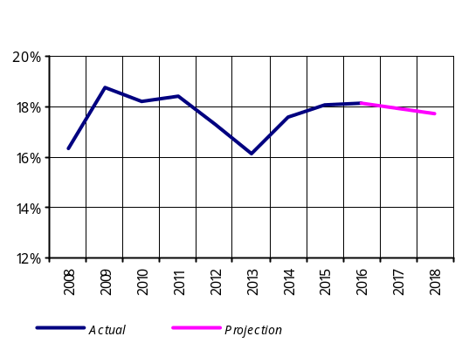

Aggregate demand
The decline of remittances from Russia will probably continue in 2016, which, howeverthe expected decline will be smaller compared to those reported in 2015. Also, given persisting weak investment activity in the economy, it is expected that private sector’s expenditures will reduce by around 1.0% in 2016 (more than the previous forecast).
The expansionary monetary policy implemented in 2015-2016, an expected low inflation environment in the economy, and a large budget deficit for 2015-2016 will significantly soften the negative impact of remittances on domestic demand in 2016.
The domestic demand will increase gradually in 2017-2018 as economic activity revives in partner countries to Armenia as well as the lagged impact of the expansionary monetary policy in the Armenian economy persists.
Though weak domestic demand will negatively affect the economic growth at the start of the forecast horizon, it will however facilitate the elimination of imbalances – particularly the closing up of the negative gap between savings and investments – observable in the domestic economy in recent years. This, in a floating exchange rate regime, boosts up competitiveness of the tradable sector of the Armenian economy, strengthens the macroeconomic stability and creates conditions for sustainable long-term economic growth.
Armenia’s economic growth in 2015 was achieved primarily by the contribution of net exports. Moreover, improved competitiveness determined more rapid productivity growth rates in tradable sector of the Armenian economy, owing to growth in agriculture, industry and services sectors reported in 2015. Given the global demand expands and investments in tradable sector increase in 2016 - 2018, net exports will continue to largely contribute to the economic growth. In the forecast horizon, revenues generated in the tradable sector will, in turn, serve a source to finance gross private expenditures and will promote the recovery of the domestic demand and economic growth on the whole.
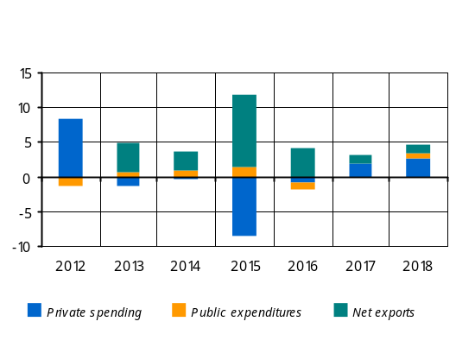
Private sector spending
Estimates suggest that continued slowing of private transfers from Russia will result in a 1.3% reduction (in real terms) of final consumption expenditures of households in 2016, which will, however, be smaller than the decline recorded in 2015. The expansionary monetary policy, a low inflation environment and net exports, with their positive effects on disposable income of households, will cushion the decline in private spending.
In2016 private spending will reduce by 1.3% in real terms.
The shrinking of remittances from Russia and weak investment activity persisting in non-tradable sectors of the economy will adversely affect private investment in 2016. On the other hand, a relatively high investment activity in the tradable sector of the economy is likely thanks to an increase in relative competitiveness of the sector, reflected in the growth in agriculture and industry sectors reported in 2015. These developments, therefore, denote that private investment in the economy in 2016 will not change significantly against 2015.
In 2016 private investment will persist at the previous year’s levels.
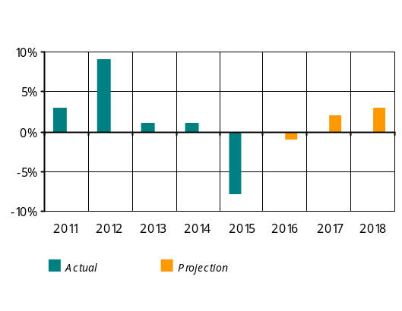Considerable loosening of monetary conditions as well as growing budget deficit will soften the decline in private consumption and investment in 2016, on the one hand, and stimulate their growth in 2017-2018, on the other. It should be mentioned, however, that since 2017 the fiscal policy will have a contractionary impact on the aggregate demand. Improvement in the external economic environment, the recovering of the Russian economy in particular, would also contribute to the fostering of demand in the private sector. In view of the aforementioned developments, private consumption is predicted to grow by 1.5-2.1% in 2017 and 2.5-3% in 2018.
In case the above incentives work, private investment will grow by 3.0-3.8% in 2017 and 4.0-5.0% in 2018. More investment in the tradable sector and continued structural reforms in the domestic economy will facilitate a moderate growth in investment. 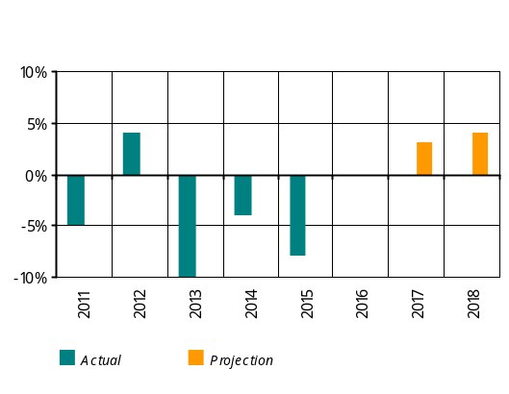On the back of these developments, a non-tradable sector of the economy – construction and trade sectors in particular – might anticipate a slowly recovering investment activity in 2017-2018, but the growth there is expected to be smaller than in the tradable sectors.
In view of the aforementioned developments with private consumption and investment, in 2016 private sector expenditures will reduce by 1.0%. Starting from 2017, private spending will gradually recover, growing in the range of 1.7-2.5%, and at the end of the forecast horizon it will stabilize within 2.5-3.5%. In the outcome, private spending gap for the period 2016-2017 is estimated to be negative although the level of private spending is set to rebound gradually in the forecast horizon.
Provided fiscal and monetary stimulus to the economy, resurging investment activity in the domestic economy in 2015-2016, as well as acceleration of economic growth in partner countries to Armenia will gradually reduce the negative private spending gap and help to phase out this imbalance at the end of 2017.
In the period of the first quarter of 2016 to the end-2017, concurrent with stabilizing inflationary expectations which are currently heightened, the private spending will create an average 1.4-1.5 pp of contractionary impact on the inflation. From the fourth quarter of 2017 up to the end of the forecast horizon, the private spending will leave no considerable impact on the inflation.

Current account
The current account deficit-to-GDP ratio for 2015 has improved and estiamted at around 3.0% compared to the previous year’s relevant figure of 7.3%. This advancement was attributable to significant improvement of the trade balance deficit in spite of the decline in remittances and factor income. The slump in the Russian economy, along with depreciating ruble, induced net dollar value of remittances of individuals via the banking system to decrease by 35.8% in 2015. In such conditions, weak domestic demand led to the contracting of real import volumes, which is estimated at around 7.0% as of the end of 2015. In 2015, however, the real growth of export of goods and services is estimated at around 14.0% and is mostly attributable to strong growth rates reported in the domestic mining and agriculture sectors amid sluggish growth in the world and, particularly, the slowdown of the Russian economy.
In 2016, the forecasts of current account components were adjusted in response to revision of relevant forecasts for both global and domestic economies. Fresh forecasts of the decline of the Russian economy as well as a new series of the ruble depreciation in January of 2016 urged the CBA to make a downside revision for the dollar value of remittances of individuals. The decrease is expected to be within 9.0-12.0% in 2016. In this case, with real disposable incomes diminishing considerably, the real declining rates in import of goods and services will go even farther, compared to the previous prediction, to 6.0-8.0%. Similarly, the growth rates in export of goods and services will slow down against the previous forecast to 2.0-4.0%, as a result of downside revision of global economic growth rates.
The above predictions suggest that the current account deficit-to-GDP ratio will rise in 2016 to be within 4.0-5.0%. In a mid-term perspective, the current account deficit-to-GDP ratio will be in the range of 3.0-4.0%.
The fiscal policy’s impact on overall demand for 2016 has been assessed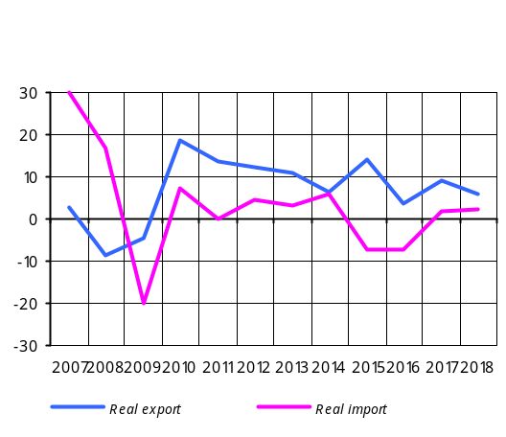 by reference to nominal indicators of the budget, laid down in the Republic of Armenia Law on “State Budget 2016”. The assessment predicts a 0.1 pp increase of the tax-to-GDP ratio and a 1.0 pp decrease of the expense-to-GDP ratio against the 2015 preliminary indicators. Note that the expenses will reduce owing to current expenditures. As a result, the deficit-to-GDP ratio in 2016 will reach 3.5% of GDP.
In 2016, relative to 2015, the fiscal impulse is expected to leave 1.4 of contractionary impact on overall demand, with budget revenues to create 0.2 of expansionary effect and expenditures to have 1.6 of contractionary effect. The effect is forecast to be neutral in the first quarter and contractionary over the rest three quarters of the year.
In 2016 the fiscal impulse is expected to leave 1.4 of contractionary impact on overall demand.
Notwithstanding the fiscal impulse leaving a contractionary impact on overall demand, the budget deficit as planned under the Republic of Armenia Law on “State Budget 2016” is estimated to be high – in 2016 it will reach 3.5% when the average annual deficit-to-GDP ratio is 2.4% in the last 5 years.
The projections of the fiscal policy in the forecast horizon are based on the forecasts of the main nominal indicators in the Republic of Armenia Medium-Term Public Expenditures Program for 2016-2018. In the medium run the fiscal policy is aimed at gradual reduction of the budget deficit in line with the sustainability of public debt. The impact of fiscal policy is estimated to be contractionary in 2017 and neutral in 2018.

Medium-term fiscal policy impact assessment
% in GDP | 2014 | 2015 | 2016 | 2017 | 2018
Budget revenues | 22.8 | 22.0 | 21.9 | 22.5 | 22.6
Budget expenditures | 24.7 | 26.4 | 25.4 | 24.4 | 24.2
Debt interest payment | 1.2 | 1.5 | 1.8 | 1.8 | 1.7
Budget balance | -1.9 | -4.4 | -3.5 | -1.9 | -1.6
Primary balance * | -0.7 | -2.9 | -1.7 | -0.1 | 0.1
One-off flows ** | -0.6 | 0.0 | -0.4 | -0.6 | -0.5
Adjusted balance *** | -0.1 | -2.9 | -1.3 | 0.5 | 0.6
Cyclical balance **** | 0.0 | -0.3 | -0.3 | 0.0 | 0.0
Cyclically adjusted primary balance (structural balance sheet) | -0.1 | -2.6 | -1.0 | 0.5 | 0.6
Fiscal stance ***** |  | 2.4 | -1.6 | -1.5 | -0.1
* Budget balance less debt interest payments.
** Temporary or one-off budget entries. In this case net lending is considered; the sign “+” means resources allocated and the sign “–” means resources repaid.
*** Primary balance sheet adjusted by temporary or one-off entries.
**** The CBA estimate: a part of the budget balance which depends directly on the business cycles. The latter’s components depend on the GDP gap and revenues and expenditures elasticity coefficients on GDP gap.
***** The CBA estimate: y/y change in the structural budget balance that reflects a discretionary nature of the fiscal policy (the positive sign denotes fiscal expansion and the negative sign denotes fiscal contraction).
Summary: from the first quarter of 2016 up until the end of 2017 the combined impact of the fiscal policy, private demand and labor market on domestic prices will be deflationary, in the range of 1.6-1.8 pp. This will be determined by predominantly deflationary impact of private spending amidst stabilizing inflation expectations. Also, given the 0.4-0.5 percentage point inflationary impact of net external demand, one may conclude that overall aggregate demand and labor market developments in the above-mentioned period will create on average 1.2-1.3 percentage point deflationary pressures in the consumer market.
Starting from the fourth quarter of 2017 up until the end of the forecast horizon, the impact of overall aggregate demand and labor market on inflation is estimated to be neutral.

2.3. Inflation forecasts and monetary policy directions in 3-year forecast horizon

The fourth quarter of 2015 saw trends of slow economic growth rates in Armenia’s main partner countries, with an exception of Russia which reported deeper economic decline against the previous quarter. The economic downturn in Russia, however, was slower – an estimated -4.0% instead of -4.7% forecasted for 2015. In the meantime, the global demand remained sluggish, which, coupled with increased supply factors in product markets, made it possible for deflationary patterns to linger in commodity and food product markets of the world. The developments in food product markets were generally in line with forecasts, whereas commodity markets saw even a deeper deflationary environment against anticipation.
In the forecast horizon, global economic growth will continue at a slow pace; while economic growth rates tend to speed up in developed countries, sluggish growth rates will linger in developing countries. In view of geopolitical and in-country economic developments, the Russian economy will keep on declining over 2016, which will be deeper compared to the previous forecast. Specifically, a 1.8% economic slump is expected in 2016 (previous forecast: 0.2% decline), which will continue up to mid-2017, gradually approaching a level of 1.4% growth in the forecast horizon. Meanwhile, the risks and uncertainties about further pace of the global economy, pinpointed in the previous forecast, will be persisting. They are associated with anticipated interest rate increase by the U.S. Federal Reserve System and the consequences it could bring. On the other hand, there are significant risks to how the Russian economy will develop in the light of geopolitical and in-country economic situation, how economic development prospects will unfold in China and what there can be after Iran’s entry into the global oil market.
With global economy still sluggish and excess supply observed in individual commodity markets, the external sector will see even more pronounced deflationary patterns against the previous forecast, which will persist in the short run. International prices of commodities and food products are predicted to stabilize at a certain low level in the forecast horizon as global demand recovers gradually and production volumes shrink.
In the fourth quarter of 2015, the domestic economic growth rates were estimated within 2.7-2.9%, slightly lower from expectation, which is explained by downward revision of economic growth in the first half of 2015 (from 4.0% to 3.6%) because of developments in the industry and services sectors in 2015. The estimation, therefore, is that the economic growth in 2015 will also be lower from forecast, making up 3.1-3.3%. The tradable sector of the economy, agriculture and mining in particular, which saw strong productivity growths at the beginning of the year, will serve as the main driver to the economic growth.
In the fourth quarter of 2015, with the ruble depreciating against the dollar and the Russian economy further slowing down, the dollar value of net inflow of private remittances and seasonal worker pays diminished at a slower pace against the previous quarter, but was nevertheless higher than expected, thus keeping the gap in real private remittances still negative. Under this circumstance, the decline in the dollar value of net inflow of private remittances in 2015 was more than expected, amounting to 35.8%.
The decrease of private remittances, slower growth rates in lending and still sluggish construction activity made the domestic demand more fragile than expected in the fourth quarter, reflecting both considerable reduction in private spending and persistently weak investment environment. In this case, the decrease in domestic demand in 2015 is estimated around 6.0%, which is more than anticipated. Note that the decrease in domestic demand was somehow cushioned by more expansionary fiscal policy implementation during 2015, considerably loosened monetary conditions, and a low inflation environment at the time. Under faster growth of productivity in the tradable sector of the domestic economy that secured high growth in agriculture and industry, the external demand kept on improving during the quarter along with adjustment of the negative current account. This facilitated real export to post higher than expected growth rates amid a decrease in real volumes of import.
As a result of the above developments, in the fourth quarter of 2015 the GDP gap is more negative compared to the previous forecast. Given that the external sector’s deflationary effects were partly transmitted onto domestic prices, the 12-month core inflation rate subdued by 3.7 pp to 0.7%12 at the end of December. At the same time, favorable developments in agriculture sector resulted in a significant decrease in prices of agricultural products during the quarter compared to the same reference period last year. In view of the aforementioned developments, the 12-month inflation rate fell more rapidly than expected to -0.1% late in the year instead of the forecast 2.5%. It should be noted that a low inflation environment in 2015 has somewhat mitigated the households’ inflation expectations which, however, remain relatively high in the light of downside rigidity of core inflation.
In view of a low inflation environment and the lack of inflationary effects due to weak external and domestic demand, the monetary conditions were loosened notably in the fourth quarter of 2015 as the CBA reduced the refinancing rate in November-December by 1.5 pp to 8.75%. It was estimated that inflationary risks arisen from the previous year-end had been largely overcome, and solid easing of monetary conditions made it possible to return to the normal situation that existed before November of 2014.
According to macroeconomic forecasts of the CBA, starting from the second quarter of 2016 economic growth rates will slow down to some extent, which will be explained by reducing domestic demand and decelerating of high growth rates in productivity in agriculture and industry sectors. In this circumstance, economic growth in 2016 is expected in the range of 1.5-2.6%, which will not change much relative to previous forecasts.
In consideration of the actual developments and estimation of a deeper downturn in the Russian economy, the 2016 forecasts of the dollar value of net inflow of remittances were revised downside. As a result, in consideration of persistently weak construction activity, the private spending is expected to reduce even more in 2016 compared to the previous forecast, which, however, is much smaller than the decline recorded in 2015. Moreover, the decline in private spending will be attributable to private consumption to be reduced more than expected, as well as lingering sluggishness in investment activity. At the same time, considerably loosened monetary conditions, a low inflationary environment in 2015-2016, and the lingering effects of the fiscal policy implementation in 2015 will somewhat ease the negative impact of private sector expenditures on the domestic demand in 2016. In view of a weak domestic demand and strong productivity growth rates in the tradable sector, the external demand will continue to improve during 2016. With export growth rates decelerating against the previous year, the said improvement of the external demand will occur through more contraction of real import volumes. The negative GDP gap shaped as a result of these developments will persist until the first half of 2016 and will reduce to some extent starting from the second half of the year only.
In the period 2017-2018 however, the domestic demand will rebound gradually amid recovering growth rates in private remittances, improving external economic environment and implementation of a number of projects by the Government to promote the tradable sector. In the meantime, external demand will continue contributing to the economic growth. In the outcome, the GDP gap, still in the negative territory, will gradually reduce in 2017 to approach zero at the end of the forecast horizon. Based on the above mentioned developments, it is expected that economic growth will speed up to a 3.0-4.5% range at the end of the forecast horizon, which will be largely driven by the tradable sector of the economy. The economic growth forecasts, nevertheless, greatly depend on investments in the private sector, the scale, directions and effectiveness of the projects carried out by the Government as well as on how the developments in the external sector will unfold.
As for the 2016 inflation developments, no significant inflationary pressures are expected from the domestic economy and external sector, so a weak deflationary environment will persist in the short run, contributing to the maintaining of the purchasing power of incomes and gradual decrease in inflation expectations. The inflationary effect from the change in the excise duty as scheduled for May 2016 has been considered in the inflation forecasts. The CBA, therefore, anticipates that the above pressure will expand gradually in the upcoming months and the inflation rate will approach and stabilize around the target in the forecast horizon.
Inflation (12-month) Forecast Probability Distribution Chart for a 3-year horizon

As a result, the CBA considers to keep on easing the monetary conditions in the first quarter of 2016. This, coupled with loosened monetary conditions early in the year, will drive the aggregate demand to expand and the inflation to stabilize around the target in the forecast horizon. Moreover, gradual loosening of monetary conditions is important on the premise of relatively high inflation expectations and the risk to downside price rigidity and increasing dollarization.

Period | Inflation interval forecast probability distribution
Period | <1.0% | 1.0-2.5% | 2.5-5.5% | 5.5-7.0% | >7.0%
Q1, 2016 | 99.1 | 0.9 | 0.0 | 0.0 | 0.0
Q2 | 86.9 | 12.4 | 0.7 | 0.0 | 0.0
Q3 | 65.9 | 28.5 | 5.6 | 0.0 | 0.0
Q4 | 35.4 | 37.5 | 26.9 | 0.3 | 0.0
Q1, 2017 | 23.3 | 34.7 | 40.6 | 1.3 | 0.1
Q2 | 23.2 | 33.4 | 41.1 | 2.1 | 0.2
Q3 | 12.4 | 27.1 | 54.1 | 5.6 | 0.8
Q4 | 7.5 | 21.4 | 59.8 | 9.5 | 1.8
Q1, 2018 | 6.3 | 19.1 | 60.4 | 11.6 | 2.6
Q2 | 5.1 | 16.3 | 60.0 | 14.5 | 4.1
Q3 | 4.7 | 15.4 | 59.8 | 15.4 | 4.7
Q4 | 4.8 | 15.5 | 59.5 | 15.5 | 4.8

Risks to inflation deviating from the projected value are estimated to be downside in the short run and balanced in the medium run. The downside risks are mainly attributable to the falling prices of commodities and food products in the international markets and a spillover of greater impact of such price reduction on domestic prices as well as to the developments in prices of agricultural products. In the medium-term perspective, the risks deriving from domestic and external sectors are mostly persisting in relation to the previous forecast. In particular, the external sector risks are related to the global economic decline and drop in international prices of commodities and food products driven by capital outflows from developing countries to the U.S.A., higher volatilities of currencies in developing countries and a sharp slowdown in Chinese economic growth. Risks deriving from the domestic sector are mostly associated with the developments in agriculture, a sector greatly depending on weather conditions, the pace at which domestic demand and private investments will recover, as well as Government-led promotion programs. If the aforementioned risks materialize, the CBA will react accordingly by maintaining the inflation target in the medium run.
In 2016 the lending supply will persist, which will further be fueled by various lending programs under a number of international financial institutions (World Bank, Asian Development Bank, KfW Bank, European Investment Bank) carried out through the Central Bank in cooperation with the Government, loan projects with relatively low interest rates under social security programs (Housing for Youth, the National Mortgage Company) and replenishment of capital which the banks are required to complete in 2016. The latter factor together with growing economic activity will certainly facilitate the lending.
In the long-term perspective, the CBA will continue to respond to changes in demand for liquidity by delivering a policy rate at an appropriate level, altering the mechanism of reserve requirement as and when needed and taking up other macro-prudential measures, while following the priority of price stability.

3. Actual Developments in Q4, 2015

3.1. Inflation

3.1.1. Actual inflation and fulfilment of the inflation target
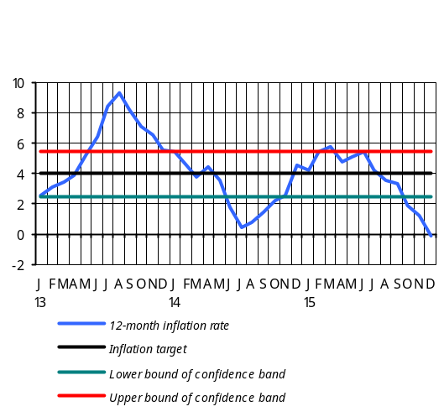The fourth quarter of 2015 saw 1.9% inflation (compared to 5.4% inflation in the same reference period last year) due to 2.7% and 2.1% rise in prices of food products and services (total contribution to inflation: 2.0 pp). During the quarter, prices of non-food products reduced by 0.2%, with their contribution of -0.1 to inflation. The low level of inflation was almost entirely due to prices of agricultural products having reduced against the same reference period last year and to the external sector’s deflationary impact partly transmitted on to the domestic prices. As a result, the 12-month inflation rate stood below the projected level, reaching -0.1% in late December.
At the end of 2015 the 12-month inflation rate amounted to -0.1%:
Strong growth rates in domestic agriculture on the one hand and a sluggish demand in the economy on the other pushed fruit and vegetable prices down to a level lower than the one in the previous yearend. Specifically, the fourth quarter saw 8.5% deflation in the group “Fruit”, while the group “Vegetable and Potato” reported relatively low 42.6% inflation (total contribution to inflation: 2.1 pp). Groups such as “Meat products”, “Fats and Oils” and “Pastry” reported decreased prices (total contribution to inflation: -0.25 pp), whereas price inflation was recorded in the groups “Eggs”, “Dairy products” and “Sugar” (total contribution to inflation: 0.2 pp).
In the group “Services” the housing and utility, public catering and household service fees rose by 4.1%, 5.9% and 1.6%, respectively. The increase in the housing and utility service fee was entirely due to a 10.4% rise in the electricity tariff13. On the contrary, the transport, healthcare and rest and leisure service fees reduced by 2.2%, 0.8% and 1.6%, respectively.
Non-food price deflation was mainly attributable to the prices of such import goods as private cars and fuel, detergents, medicament and household appliances, having dropped by 2.0%, 3.4%, 0.2% and 0.8%, respectively. A low seasonal price increase of 2.6% and 1.3% in the groups “Garment and Knitwear” and “Footwear” also contributed greatly to the deflation of prices of non-food products.

Inflation by groups serving as key contributors
Group | September 2015 (y/y) |  | December 2015 (y/y) |  | Fourth quarter 2015
Group | Growth (%) | Contribution | Growth (%) | Contribution | Growth (%) | Contribution
CPI | 3.3 |  | -0.1 |  | 1.9
Food products | 2.3 | 1.1 | -3.7 | -1.81 | 2.7 | 1.32
Bread products | 5.3 | 0.5 | 0.4 | 0.04 | 0.1 | 0.01
Dairy products | 2.7 | 0.1 | -4.7 | -0.22 | 0.9 | 0.04
Meat products | 1.5 | 0.1 | -3.7 | -0.35 | -2.4 | -0.23
Fruit | -4.8 | -0.2 | -19.5 | -0.66 | -8.5 | -0.29
Vegetable and Potato | 12.6 | 0.7 | -4.0 | -0.23 | 42.6 | 2.39
Fats and Oils | -4.6 | -0.1 | -7.9 | -0.23 | -0.5 | -0.01
Eggs | -16.6 | -0.3 | -20.2 | -0.31 | 7.8 | 0.12
Sugar | -2.1 | 0.0 | -10.1 | -0.08 | 0.6 | 0.00
Pastry | 14.1 | 0.2 | 11.3 | 0.15 | -0.3 | 0.00
Non-food products | 6.1 | 1.3 | 3.4 | 0.7 | -0.2 | -0.05
Services | 1.6 | 0.5 | 3.2 | 0.98 | 2.1 | 0.64

In the fourth quarter of 2015 core inflation decreased by 0.3%, while the 12-month rate fell by 3.7 pp to 0.7% in late December.
In the previous one-year horizon that covered the year 2015, under influence of developments in the world and the region in end-2014, the 12-month inflation rate was to increase a little at the beginning of the year. Then, following the tightness in Armenia’s financial and commodity markets, notably reduced thanks to loosened monetary conditions, and in expectation of weak demand in both external and domestic economies, the inflation was to decline gradually to approach the target at the end of the year.
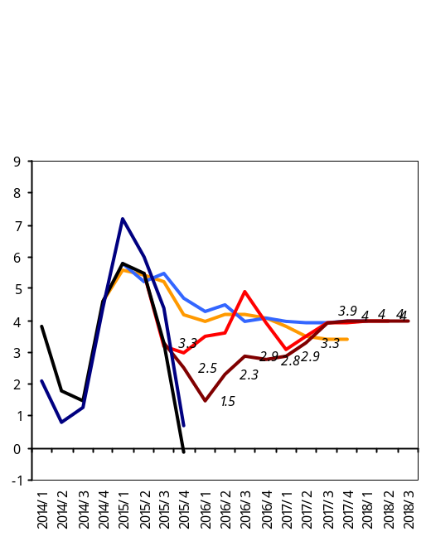
In the first quarter of 2015 the inflation environment expanded, as it was expected: at the end of March the 12-month inflation rate rose to 5.8% resting close to the upper bound of the confidence band (4+/-1.5 pp). Then, it was estimated that high inflation expectations came rather mitigated in the first quarter of 2015 after strictly preventive monetary policy carried out by the CBA in late 2014, which led the tightness in domestic financial and product markets to phase out in general. In view of this development, the CBA loosened the monetary conditions considerably during the first quarter of 2015; starting early in the year, the CBA gradually reduced the Lombard Repo Facility Rate from 20% to 12%. At the same time, the CBA raised the Refinancing Rate to 10.5% with the aim to retain the monetary position of the Republic of Armenia over a longer-term perspective, reflecting upward trends of investment risk and interest rates in developing countries.
12-month inflation rate net of seasonal products
Q1, 2015 forecast
12-month inflation rate
Q2, 2015 forecast
Q4, 2015 forecast
Q3, 2015 forecast

.

Ï³ÝË³ï»ëáõÙ
These actions not only allowed the CBA to secure the Lombard Repo Facility Rate an accepted 1.5 percentage point spread from the Refinancing Rate but also pushed short-term market rates down.
Other macro-prudential measures in the first quarter of 2015 in addition to the interest rate change included introducing a zero or weak mechanism of reserve requirement to banks , when they borrow long-term funds, and mitigating the requirements to resident non-financial corporations and reducing risk weights ascribed to foreign currency loans of borrowers active in export businesses, provided that they have external credit rating.
In the second and third quarters of 2015 inflationary developments were largely in line with the scenario. Thus, easing gradually while embracing positive developments reported in agriculture, the inflation environment ended with a 4.2% price deflation (food products’ contribution to headline inflation: -4.3%), in which circumstance the 12-month inflation rate has reduced from 5.8% in March to 3.3% in end-September. In view of the inflation environment then at a lower level and non-inflationary pressures unlikely to come from weak external and domestic demand, the CBA lowered the Refinancing Rate by 0.25 pp to 10.25% in August. The inflationary risks and uncertainties for the upcoming year urged the CBA to adjust its inflation forecasts downside in the third quarter, in anticipation of even more volatile patterns for it.
The existing low inflation environment notwithstanding, the CBA refrained from loosening the monetary conditions any further up until mid-November, since a relatively high level of the 12-month inflation rate, net of seasonal goods, reaching 4.5% on average in the period August-October, pointed to still high inflation expectations.
The fourth quarter of 2015 saw the 12-month inflation rate declining faster than expected, which was primarily determined by a larger supply of agricultural products. This means that a recent price falling in external sector was partially reflected in domestic prices at the yearend thus easing high inflation expectations. As a result, inflation was merely 1.9% in the fourth quarter instead of 5.4% recorded in the same reference period of last year, in which case the 12-month inflation rate reached a negative value, -0.1%, in late December.
In this situation, the CBA kept on easing monetary conditions in November-December by reducing the refinancing rate by 1.5 pp to 8.75% later the year. It was estimated that inflationary risks arisen from the previous year-end had been largely overcome, and solid easing of monetary conditions made it possible to return to the normal situation that existed before November of 2014.

3.1.2. Import prices and producer prices
Import prices: in the fourth quarter of 2015 dollar prices of import of goods and services fell by 1.9% q/q, but y/y rates of declining slowed down to 10.7%. The y/y reduction in dollar prices of import was driven by prices of goods and services having fallen by 8.5 and 2.2 pp, respectively. The decrease in dollar prices of import of goods was assisted by the drop in prices of intermediate goods. The latter was mainly due to falling international prices of oil, iron ore, wheat and aluminum, as well as the depreciation of the currencies of the partner countries.
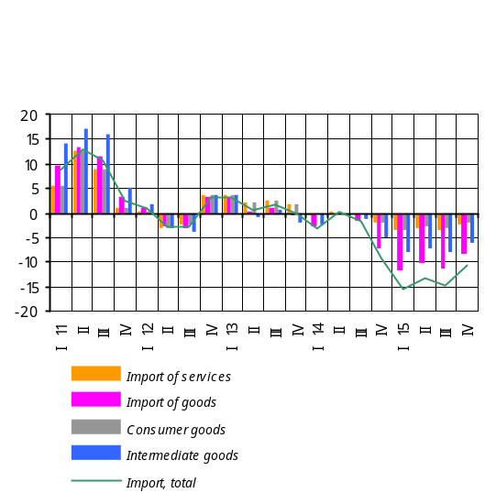 The y/y falling of dollar prices of consumer goods was largely driven by y/y decrease in dollar prices in the Eurozone, Russia and Turkey. Consumer goods had a 2.1 pp of negative contribution.
Producer prices14: in 2015 all sectors of the economy, except for agriculture and mining, posted increased price indices. As a result, the growth of GDP deflator amounted to 2.4% y/y, according to the CBA estimates.
Industry had just a minor price change during the year, since growths in processing industry (2.9%) and energy and gas production and distribution (10.3%) were offset by 22.0% deflation reported in mining due to falling prices of ores and metals in world markets.
Agriculture reported a 19.5% y/y drop in prices15 in the period January-December, driven by as much as 35.5% y/y plunge in prices in plant growing as a result of abundant crops. The decline in price in animal breeding was somewhat smaller, 3.9% y/y.
The price deflation in plant growing was driven mainly by decreased prices of fruits and berries (51.8%), potato and gourds and melons (7.1%), and grain (11.7%).
Services reported a 3.0% y/y rise in prices in the period January-December, determined by growths in household services (6.6%), medical services (5.2%), recreational services (18.8%) and public catering services (8.5%). The slackening of domestic demand observable since the start of the year notably affected the communications and transport sub-sectors, which posted 1.7% deflation and merely 0.3% inflation, respectively.
Construction reported a 6.1% y/y price-rise in the period January-December, driven by increased costs in construction and assembly works (5.3%), equipment and materials (4.2%) and other related expenses (12.2%). Note that the inflation on other expenses is primarily due to a wage growth.
Carriage posted a 1.2% y/y rise in tariffs in the period January-December, owing to increased fare for railroad transport (10.8%).
3.1.3. Inflation and interest rate expectations
The financial sector survey by the CBA for the fourth quarter of 2015 denote that households’ inflation expectations16 for an upcoming one-year horizon have weakened notably, reflecting an abruptly down-sloping path of actual inflation. Moreover, the prices of goods, net of seasonal agricultural products, dropped considerably at the end of the year. However, the inflation expectations are thought to be relatively high in spite of a low inflation environment, and this points to a downward rigidity in prices of import goods, non-fundamentals-backed expectations for dram depreciation and the risk to increased dollarization of the economy.
During the quarter, the CBA continued its surveys with the financial sector and households for their expectations of selected macroeconomic indicators. The financial sector’s inflation expectations for an upcoming one-year horizon continued diminishing. Thus, banks had their expectations of the 12-month inflation rate anchored around a 4.3% level, which is more or less the same indicator of the previous survey; credit organizations’ expectations have averaged 4.3% compared to the previous indicator of 4.7%; households had their inflation expectations of the 12-month inflation rate around a 2.8% level compared to a relevant indicator of 3.6% reported in the previous quarter’s survey.
The expansionary monetary policy carried out by the CBA in 2015 affected the domestic financial market’s performance by pushing interest rates downward. This, in turn, reflected the financial sector’s expectations for interest rates. This quarter the financial sector anticipates that, in a one-year horizon, interest rates of funds attracted and allocated will trend downward. Moreover, interest rates of loans and those of foreign currency funds are expected to drop relatively fast.

Box 2

Inflationary expectations

The inflation expectations of people are essential in formulation and implementation of monetary policy. This is because the society’s expectations regarding consumer prices affect the shaping of the level of both current and future prices, as firms and businesses adjust their behavior based on these expectations. Therefore, the effectiveness of monetary policy largely depends on the extent to which the inflation expectations of people are anchored around the inflation target and to which extent they are resilient to different types of supply shocks. In this sense, central banks are always attaching great importance to assessing the inflation expectations as accurately as possible, using different approaches from conducting surveys to working on combined economic models. The estimates of inflation expectations are used both to identify the society’s perceptions about further behavior of consumer prices and verify the transparency and credibility of the implemented monetary policy, and as a variable explaining the future behavior of inflation and leading indicator in economic models and analyzes.
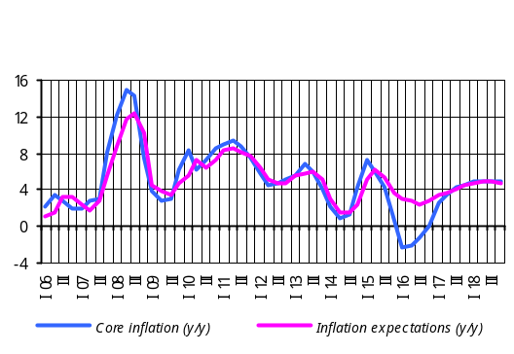The inflation expectations and assessment thereof are also essential for developing the monetary policy directions and decision-making by the CBA, based on which the CBA estimates such inflation expectations both through various surveys conducted with businesses and in the context of a single economic model, i.e. the Quarterly Projection Model of the CBA. It should be noted that the QPM treats the inflation expectations of people to the previous period of inflation and the future behavior of factors that affect inflation.
According to the assessment under the QPM, the inflation expectations have eased to some extent, making up 3.6% and 3.0% in the fourth quarter of 2015 and the first quarter of 2016, respectively. These indicators, however, are standing high in a low inflation environment as assessed by the CBA. It is worth mentioning that, driven by relatively high inflation expectations, the decrease in prices of commodities and food products in the external sector has only partly been reflected in the behavior of core inflation, which fell to 0.7% y/y at the yearend.
Because high inflation expectations can lead to a series of negative consequences, the CBA finds it critical that the society anchor their high inflation expectations for the economy. Particularly, high inflation expectations can lead to increased investor uncertainty associated with future inflation, which is why companies may prefer to postpone investments, thereby hampering economic growth. In addition, high inflation expectations contribute to the reduction of savings and foster the growth of dollarization, as people are starting to buy more products and services to avoid devaluation of money on the one hand, and to have the savings in the national currency converted into savings in foreign currency on the other. Understandably, this impedes the efficient transformation of savings to investment. Finally, high inflation expectations contribute to downside price rigidities in the economy, especially when it comes to price deflation on commodities and food products, which spill over from the external sector. The latter does not allow manufacturers to reduce costs and restore external competitiveness, which negatively affects the adjusting of the economy and economic growth rates on the whole.

3.2. Aggregate supply and aggregate demand

3.2.1. Aggregate supply17
The economic growth indicator for January-September 2015, published by the National Statistics Service of Armenia, was 3.5% y/y. The indicator is slightly below the previous forecasts of the CBA,, which is explained by the fact that the first half economic growth had been revised by the NSSA to amount to 3.6% instead of previously published 4.0%.
In the period January-December 2015, the economic activity indicator has grown by 3.1% y/y, which again is slightly lower from the CBA expectations due to the revision referred to above. As a result, the 2015 economic growth will be expected in the range of 3.1-3.3%18.
The 2015 economic growth is expected in the range of 3.1-3.3%.
Given an increased output of 5.2% y/y reported in Industry in the period January-December 2015, the growth of value added there is estimated in the range of 7.0-7.4% y/y for 2015. ì This is mainly due to increased production in ore mining (51.5%), jewelry crafting (61.0%), tobacco production (49.1%), pharmaceuticals (25.1%), chemical products (10.3%) and water supply and sewage (10.1%). High growth in ore mining is determined by the start of Teghout mine operation at the beginning of the year. Despite the growth recorded in the above sub-sectors, the slack in domestic demand in Russia, a principal trade partner, led to decreased output volumes in several subsectors of industry of the Armenian economy in the period January-December. In particular, production of food and beverage, which hold a significant share in industry, has shrunk by 9.0% and 19.7%, respectively, and negatively affected the growth in there.
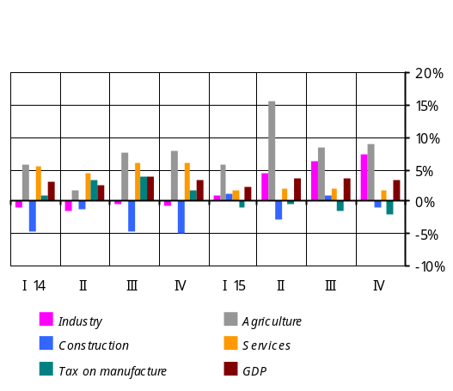 Based on actual change in output (0.3% y/y) in Construction for the period January-December 2015, the decrease of value added is estimated within 0.6-1.2% y/y. The decrement has been due to an end-year shrinkage reported in construction financed by households (11.9%), and in construction financed by organizations (27.8%). Note that around 20% increase in the volume of construction financed by international loans cushioned the overall decline in the sector.
In Services, the growth of value added is estimated in the range of 1.4-1.8% y/y for January-December 2015, which is a result of 2.7% growth in services provided but 8.0% contraction in trade turnover. The increase in the volume of services provided was driven largely by growth reported in events, leisure and rest services (68.1%), financial and insurance services (3.6%), and hotel and accommodation services (5.7%). Domestic demand, slackened as a result of narrower flow of money transfers, has negatively affected the trade turnover which, in turn, led to reduced output in transport sector thus decelerating the growth rates in the services sector. In 2015 the volumes of retail trade, wholesale trade and passenger car sales contracted by 10.1%, 4.2% and 9.8%, respectively; the volumes of trade in transportation shrank by 19.9%.
In Agriculture, the growth of value added is estimated in the range of 8.5-9.3% y/y for 2015, which is driven by increased outputin animal breeding, plant growing and fish growing, by 6.1%, 15.2% and 6.4%, respectively.
?

3.2.2. Aggregate demand19
In the fourth quarter of 2015 private consumption expenditures diminished more than it had been forecast previously and are estimated to be roughly 12.0%. This is explained by more-than-anticipated shrinkage in trade volumes this quarter. Under this circumstance, the decline in private consumption in 2015 will be around 8%.
The decline in private spending in 2015 is estimated to be around 8%.
Reduced private remittances from Russia, a trend observable since the end of 2014 and persisting in 2015, have notably diminished the households’ disposable income which, in turn, led to the reduction of private consumption expenditures in 2015. It should be noted, however, that expansionary fiscal policy carried out by the Government in the period under review, easing of monetary conditions by the CBA, as well as a low inflationary environment served a substantial cushion against declining private spending.
The results of the CBA surveys and trade turnover indices calculated by the National Statistics Service of Armenia also point to the contracted consumption in the private sector. Thus, in the fourth quarter of 2015 the Consumer Confidence Index was 41.6, which is below its stability range of 45-55, reflecting shrinkage in consumer spending in the period under review, and the Current Consumption Index was 33.2. In fourth quarter, relative to the same reference period of the previous year, trade turnover had shrunk by 13.5%, with a reported decline in wholesale trade and retail trade as well as personal car sales.
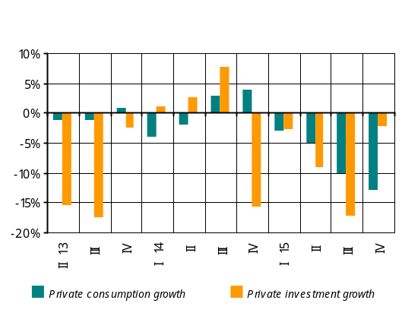In the fourth quarter of 2015 the investment climate in the economy was weak - consistent with the previous forecasts - whereby the decrease in private investment over the same period last year is estimated at about 2.0%. In this case, the decline in private investment in 2015 is around 8% and is determined by reduced domestic demand, slower growth rates in company lending as well as generally a sluggish business environment in the period under review. As outlined in the CBA’s previous forecasts, the decline in investments was more pronounced in non-tradable sector of the economy, whereas investment activity was relatively strong in tradable sector.
The decline in private investment is estimated to be roughly 8%.
The results of the CBA surveys on business environment at companies point to the aforementioned developments in investment climate in the period under review.
According to the results of the surveys, in the fourth quarter of 2015, relative to the same reference period last year, the business activity indicators in non-tradable sector (construction and domestic trade) were 34.8 and 47.7, respectively, which is below the stability value of 50.0. On the other hand, the business activity indicators in tradable industry and non-trade services sectors were above the stability value of 50.0, amounting to 51.2 and 63.0, respectively.
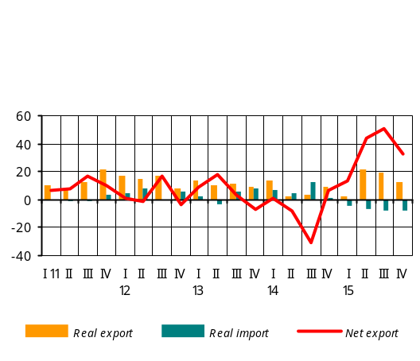In view of private consumption and investment developments described above, private spending decreased by nearly 11%. With about 12% increase in public expenditures, domestic demand is estimated to have posted 8% decline, which is smaller in relation to the slowing of private spending. As a result, the reduction of domestic demand has slowed by 6.3% for the year, assisted by expansionary effects of monetary and fiscal policies implemented during the year.
In the light of the aforementioned developments the private spending gap in the fourth quarter of 2015 is estimated to be negative, creating 3.3-3.6 pp of deflationary pressures in the consumer market. The deflationary pressures, nevertheless, did not necessitate total price adjustments since, as estimations suggested, there were high inflation expectations in the economy in the period under review.
Net export in real terms further improved in the fourth quarter of 2015, according to the CBA estimates. This was driven by high real growth in export of goods and services in the face of real decline in import of goods and services. Thus, growth rates in real export of goods and services20 amounted to 12.0% y/y amid 8.0% reduction in real volumes of import of goods and services. Persistently strong growth in domestic mining industry secured the real export growth, despite the decline in international commodity prices.
In the fourth quarter of 2015, narrowing of net inflow of non-commercial remittances of individuals via the banking system was slower than in the previous quarter, although to a lesser extent than expected, reflecting further adversities in the Russian economy in the fourth quarter.
3.2.3. Labor market21
In the fourth quarter of 2015 the average nominal wage growth rate was slower than it had been outlined in previous forecasts, and is estimated 3.1% due to slower growth of wages in the public sector relative to previous forecasts. Thus, the nominal wage growth in 2015 was 8.1%. In the period under review the average rate of growth in public sector wage has been slower from the growth rate in the private sector.
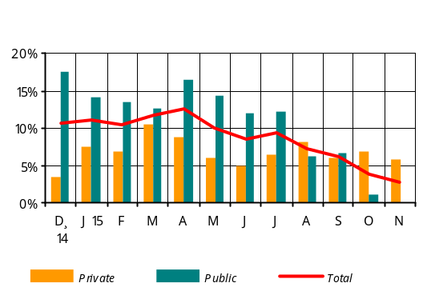 The effect of wage increasview
es in some areas of public sector since July of 2014 phased out in the second half of the year. As a result, the average annual wage growth in public sector slowed down to 4.4% in the second half of 2015. A small decrease in wages in some areas of public sector was seen in October, which led the public sector wage growth rate to further deceleration, making up 0.5% in the fourth quarter.
In the fourth quarter of 2015, the average nominal wage growth rate in private sector was 1.0 pp higher from the growth rate recorded in the same reference period last year; it amounted to 6.3% owing to increased productivity. As a result, in 2015 the average nominal wage in the private sector has grown by 7.0%.
The second quarter of 2015 saw an increase in productivity which persisted over the second half of the year, too. This resulted in reduced labor demand in the economy. As a result, the unemployment rate in the fourth quarter was in line with previous forecasts and is an estimated 18.0%, in which case the average unemployment rate amounted to 18.0% in 2015.
Productivity growth in the labor market was strong in the fourth quarter too, and was faster than the wage growth. As a result, the labor market’s impact on inflation in the fourth quarter of 2015 is estimated 0.3 pp deflationary.

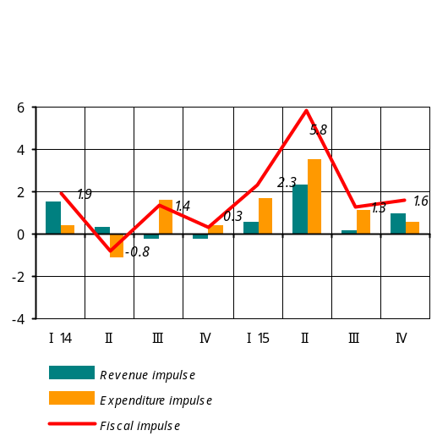3.2.4. Fiscal policy22
In the fourth quarter of 2015 the Republic of Armenia state budget performed with revenues under-collected due to a change in the tax base (the GDP growth was mainly due to growth in the agricultural sector which is not subject to taxation) and a larger amount of expenditures relative to previous quarters of the year. As a result, the fiscal policy’s impact on aggregate demand was 1.6 expansionary instead of projected 0.4, which is explained by the expenditures impulse having deviated upside.
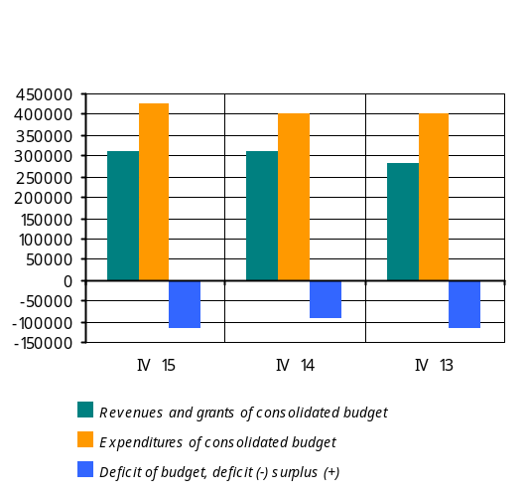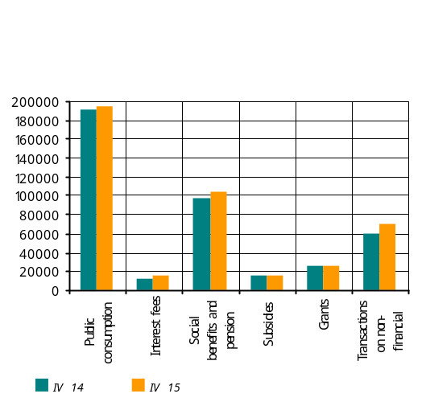In the fourth quarter of 2015, relative to the same reference period last year, revenues of consolidated budget have grown by 0.7%; tax revenues have reduced by around 2%. The share of indirect taxes has reduced by 0.2 pp to 50.2% and the share of direct taxes has grown by 4.4 pp to 40.7% of tax revenues. In the fourth quarter of 2015, relative to the same reference period last year, the decline in indirect taxes has been 3.4%. All indirect taxes, except customs duties, reported a decrease. Customs duties have grown by 28.6% against the previous reference period as a result of net proceeds (around 30% in total) Armenia received under the agreement on the Eurasian Economic Union. In the meantime, direct taxes have grown by 8.6%, owing to all types of taxes, and the share of other taxes has reduced by 4.2 pp to 9.1% of tax revenues. The revenue impulse is an estimated 1.0 expansionary, which is in line with the projection.
In the fourth quarter of 2015, relative to the same reference period last year, total expenditures have grown by 6%; current expenditures have grown by 8.3%, in which public consumption increased by 4.8%. In the meantime, expenditures on item “Transactions with non-financial assets” have decreased by 4.4%.
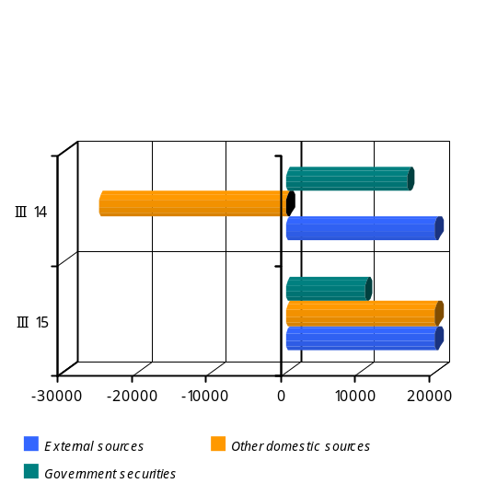In the fourth quarter of 2015, relative to the same reference period last year, the share of expenditures financed by domestic sources has reduced by 8.3 pp to 44.8% of capital expense, whereas the share of expenditures financed by foreign sources has grown to 55.2% of capital expense. The capital expense financed by foreign sources has grown by 14.1%. Seasonal patterns observed during the fourth quarter of previous year persisted in this fourth quarter too: the spending rate was around 31% of annual expenditures.
In the fourth quarter of 2015 government spending (including net lending) had a 0.6 expansionary impact on aggregate demand instead of the projected neutral.
With the above revenue and expenditure indicators, the budget generated a deficit of AMD 114.6 billion in the fourth quarter, which has been entirely financed from external sources.
Overall, based on annual results23, revenues and grants of the state budget posted a 2% increase relative to the same reference period last year. Tax revenue has grown by 0.3%. The tax-to-GDP ratio was 20.8%, a 1.1 pp smaller in comparison with the previous year. Public spending (including PIU funds) has increased by 13% relative to the same reference period last year. The year’s budget deficit totaled AMD 226.5 billion or 4.4% of GDP.
According to the year’s results, the fiscal policy has had 2.5 pp of expansionary impact on aggregate demand with revenues and expenditures having generated, respectively, 0.9 and 1.6 expansionary effects.
Summary: reduced private transfers from Russia as well as sluggish investment activity in the domestic economy dampened the spending in the private sector in 2015. However, fiscal stimulus delivered to the economy and loosened monetary conditions facilitated a slower contraction of private spending thereby mitigating the domestic economic slowdown and deflationary environment.
In 2015 the fiscal policy’s impact on aggregate demand was 2.5 expansionary.
In the fourth quarter of 2015 private spending gap is estimated to be negative. Given also that public spending and net exports demonstrated inflationary patterns but the labor market followed a deflationary path, the aggregate demand and labor market are estimated to have jointly created 2.3-2.5 pp of deflationary pressures in the consumer market in the fourth quarter. However, the deflationary pressures described above have not been fully absorbed in the consumer market as high inflation expectations remained.

3.3. Money and financial market developments

3.3.1. Financial market, money and credit
In the fourth quarter of 2015 the Board of the CBA cut the refinancing rate twice (in November and December) in view of low inflation environment that time and because it predicted that the low inflation rate would linger under influence of weak domestic demand and deflationary trends in the external sector.
In the fourth quarter of 2015 the CBA Board reduced the refinancing rate, once in November and once in December, by a total 1.5 pp.
In November the Board lowered the refinancing rate by 0.5 pp to 9.75%. The Board admitted that weak domestic demand and external deflationary environment were reluctant in reflecting the core inflation, pointing to still high inflation expectations. Meanwhile, the Board signaled that it would continue easing monetary conditions if inflation expectations diminished.
In December, a sluggish domestic demand as well as international commodity prices continuously trending downward contributed to the reduction of both inflation and future inflationary expectations. In these circumstances, the Board lowered the refinancing rate by 1.0 pp to 8.75%, announcing that the inflationary risks arisen from the previous year-end had been largely overcome as of the end of 2015, and extensively loosened monetary conditions made it possible to return to the normal situation that existed before November of 2014. The Board signaled to the financial market that it would keep on easing the monetary conditions in the event the inflation expectations are anchored and external and domestic sectors pose no more risks.
In the fourth quarter of 2015, relative to the same reference period last year, the 7-day repo rate, the main policy instrument of the CBA, has dropped by 0.75 pp to 9.97%, reacting to the gradual easing of monetary conditions and the CBA Board’s signals. In December, the average rate dropped by 1.49 pp against September to 9.58%.

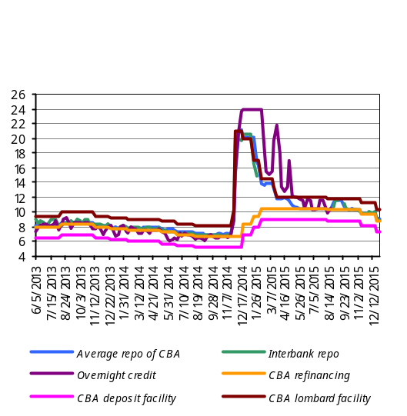
Box 3
Reserve requirement
In view of tension in global financial and currency markets, at the end of 2014 the CBA used a mechanism of reserve requirement for monetary policy purposes, including regulation of liquidity. In mid-December, the RR ratio for foreign currency liabilities was raised from 12 to 24% but late in the month, following signs of some stabilization in the foreign exchange market, the CBA lowered the ratio from 24 to 20%.
As stability was returning into the financial market, the CBA repeatedly looked to the lowering of the RR ratio during 2015:
- a zero or loose mechanism of reserve requirement for long-term funds in foreign currency attracted by banks became effective on March 1, 2015,
- a decision in late June of 2015 endorsed a change in approach to keeping reserves against funds in foreign currency attracted by banks; effective from July of 2015, reserves are kept on average weekly basis. The daily basis for keeping required reserves was abandoned,
since August of 2015, banks have switched to keeping required reserves on a two-weekly averaging basis.

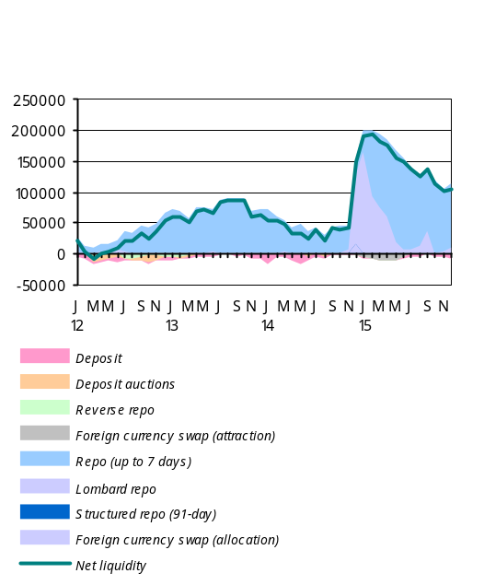

Operations carried out by the Central Bank (average transaction value)
Period | Repo (up to 7 days) |  | Funds attracted |  | Lombard repo
Period | Value  (million AMD) | Weighted average % | Value  (million AMD) | Weighted average % | Value  (million AMD) | Weighted average %
Q1, 2014 | 58769.52 | 7.80 | 8230.77 | 6.17 | 297.76 | 9.05
Q2 | 41619.24 | 7.79 | 9908.46 | 5.88 | 41.38 | 8.75
Q3 | 37331.05 | 7.16 | 3270.00 | 5.47 | 16.08 | 8.43
Q4 | 34048.94 | 10.60 | 1765.67 | 5.25 | 41550.14 | 19.69
Q1, 2015 | 95454.55 | 14.25 | 63.75 | 8.04 | 104521.49 | 16.27
Q2 | 141919.97 | 11.02 | 1857.26 | 9.00 | 27967.60 | 12.00
Q3 | 119429.03 | 10.72 | 3639.62 | 8.95 | 17089.82 | 11.78
Q4 | 107621.63 | 9.97 | 6496.15 | 8.17 | 4048.49 | 11.07
In the financial market in the fourth quarter of 2015, the interbank repo rate trended in line with the policy rate of the CBA: the average interest rate in December stood at 9.75%, having fallen by 1.66 pp against September.

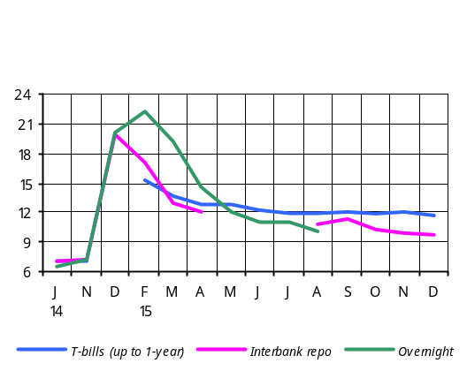
Box 4

Government securities market
In the fourth quarter of 2015 the T-bills’ yields more slowly reacted to the falling of money market rates, which is partly due to an increased volume of issuance of bonds.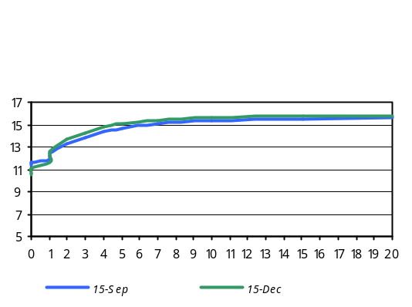 Average quarterly yield of T-bills remained almost unchanged against the previous quarter. In December, average monthly yield was 11.7%, representing a 0.4 pp drop relative to September.
The falling of interest rates in the fourth quarter of 2015 influenced primarily the short-term segment of government securities by squeezing yields in there. In late December, relative to September, the yield curve has grown almost the entire length: the long-term rate reached 15.8%, a 0.2 percentage point increase against September. Moreover, on the back of a decrease in short-term rates, the long-term and short-term interest rates spread widened in December by 1.1 pp to 5.3 pp.

In the fourth quarter of 2015 interest rates of deposit and loan resources reduced to some extent, as the CBA continued easing the monetary conditions. However, interest rates of dram deposits persisted at a high level: relative to the previous quarter, the dram deposit rates rose by 0.3 pp to 15.1%. Such interest rate increase this quarter, which was most evident in respect of funds with up to 1-year maturity, was concurrent with increasing volume of dram deposits attracted: during the quarter the dram deposits grew by 9.4%.
A low level of dram liquidity, high interest rate of reserve requirement mechanism for funds attracted in foreign currency differently affected foreign currency funds attracted by banks, depending on maturity of these funds. Thus, interest rates of foreign currency deposits with up to 1-year maturity plunged, while reduced costs for attracting long-term foreign currency funds by banks after repeated easing of the reserve requirement mechanism for foreign currency funds pushed interest rates of FX funds slightly up in the fourth quarter of 2015. Relative to the previous quarter, average quarterly interest rate of foreign currency funds attracted by banks has dropped by 0.3 pp to 6.7%. The average interest rate in December stood at 6.6%, having dropped by 0.5 pp against September. Despite the decline in interest rates, the volume of deposits in foreign currency has grown by 7.9%.
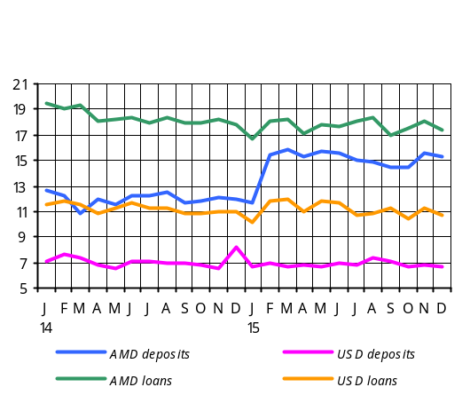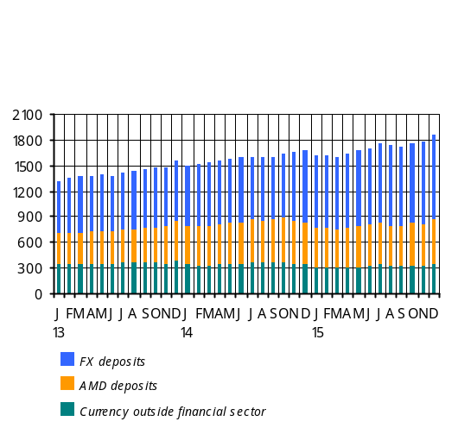Average quarterly interest rates of both local currency and foreign currency loans posted a 0.1 pp drop. This quarter, average quarterly interest rate of dram loans amounted to 17.7% and that of foreign currency loans, 10.8%. In December, average quarterly interest rate of foreign currency loans was 10.7%, having fallen by 0.5 pp against September. The decline in interest rates of FX loans was in part determined by an eased reserve requirement mechanism for long-term funds attracted by banks in foreign currency.
In spite of interest rates trending downward, lending volumes increased this quarter by 1.4%. The loans to households accounted for the largest increase, amounting to 1.2%. By currency, the dram loans grew by 2.6% and FX loans, by 1.1%. The loans in foreign currency further prevail (approximately 64%) in total lending portfolio. In December of 2015 lending volumes contracted by 3.3% y/y.

Box 5
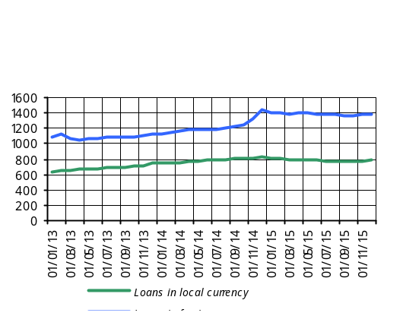
The results of Q4, 2015 survey on terms of lending by Armenian banks and credit organizations show that financial institutions tightened the provision of business and mortgage loans. The tightening embraced such aspects as collateral requirements, assessment of creditworthiness, loan-to-value ratio. On the contrary, certain terms were eased in consumer lending, especially in respect of the loan interest rate, maturity and review of creditworthiness. In the period under review, the demand has grown for consumer and mortgage loans, whereas the demand for loans to enterprises remained unchanged.
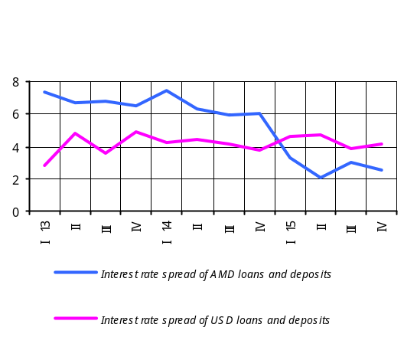For the first quarter of 2016, banks and credit organizations anticipate some easing of procedures for all types of credit along with a growing demand for household and SME lending. The demand for loans to big companies is expected to decline, however.

In the fourth quarter of 2015, the spread of interest rates of loans and deposits in local currency narrowed, with an average quarterly indicator having reduced by 0.4 pp against the previous quarter to 2.6 pp. On the contrary, the spread of interest rates of loans and deposits in foreign currency widened slightly owing to interest rates of deposits having dropped to a greater extent than interest rates of loans. The spread widened by 0.2 pp against the previous quarter. In December, the average quarterly indicator was 4.1 pp, having reduced by 0.1 pp relative to September.
In the fourth quarter the indicator of dollarization (foreign currency deposits-to-broad money ratio) dropped by 0.4 pp against the previous quarter.

Monetary indicators | December 14, 12-month growth | March 15, 12-month growth | June 15, 12-month growth | September 15, 12-month growth | December 15, 12-month growth
Broad money (%) | 8.3 | 4.1 | 6.3 | 7.3 | 10.8
Dram broad money (% ) | -3.5 | -4.4 | -4.2 | -8.6 | 5.2
Base money (%) | -0.2 | 1.61 | 14.7 | 22.1 | 3.9
Dram base money (%) | 15.5 | 19.6 | 19.6 | 15.7 | -1.6
Currency (% ) | -9.4 | -9.8 | -6.7 | -10.6 | -0.8
Deposits in local currency (% ) | 1.4 | -0.5 | -2.5 | -7.2 | 9.6
Deposits in foreign currency (% ) | 22.7 | 13.0 | 17.9 | 26.2 | 16.3
 | Dec. 14 | Mar. 15 | June. 15 | Sept. 15 | Dec. 15
Dollarization (rate) | 50.7 | 51.6 | 51.2 | 52.6 | 52.2
Money multiplier (rate) | 1.89 | 2.02 | 2.06 | 1.95 | 2.01
Dram multiplier (rate) | 1.09 | 1.11 | 1.15 | 1.15 | 1.17

3.3.2. Exchange rate
In the fourth quarter of 2015 trade partner countries saw depreciation pressures in their foreign exchange markets. The average weighted nominal exchange rate of the partner countries depreciated versus the US dollar by 2.4% during the quarter, which was largely driven by depreciation of the Russian ruble and euro (contribution: 0.9 and 0.5 pp, respectively). With partner countries’ national currencies depreciating, the average nominal exchange rate of the Armenian dram appreciated versus the US dollar by 0.2% in the fourth quarter. To absorb any short-term volatilities in the foreign exchange market, the CBA sold nearly USD 40 million in net terms.
In face of trade partners’ currencies further depreciating against the US dollar, the nominal effective exchange rate of the Armenian dram posted an average 2.5% q/q appreciation in the fourth quarter. With relatively high average weighted inflation in partner countries (e.g. price inflation in Russia and Iran), the real effective exchange rate has appreciated by 2% q/q 24.
In the fourth quarter, relative to the same reference period of the last year, the real effective exchange rate has appreciated by 1.9%.
Growth y/y, (%) | Q4, 2013 | Q1, 2014 | Q2 | Q3 | Q4 | Q1, 2015 | Q2 | Q3 | Q4
Real effective exchange rate (+ means appreciation) | 6.8 | 8.5 | 7.8 | 3.1 | 9.2 | 11.7 | 6.7 | 6.2 | 1.9
Average inflation in Armenia | 6.4 | 4.6 | 3.3 | 1.0 | 3.2 | 5.2 | 5.1 | 4.0 | 0.8
AMD/USD average nominal exchange rate (+ means appreciation) | 0.2 | -0.4 | 0.5 | 0.0 | -5.7 | -13.9 | -13.4 | -14.8 | -10.1
Average weighted inflation in trade partner countries | 4.0 | 3.7 | 4.4 | 4.6 | 5.1 | 6.7 | 7.9 | 7.3 | 7.0
Trade partners’ average weighted nominal exchange rate (+ means appreciation versus dollar) | -4.3 | -8.0 | -8.6 | -7.0 | -18.5 | -32.1 | -27.2 | -29.3 | -20.7
Real exchange rate appreciation = Inflation in Armenia + Nominal exchange rate appreciation – Trade partners’ average weighted inflation – Trade partners’ average nominal weighted exchange rate appreciation.

Box 6

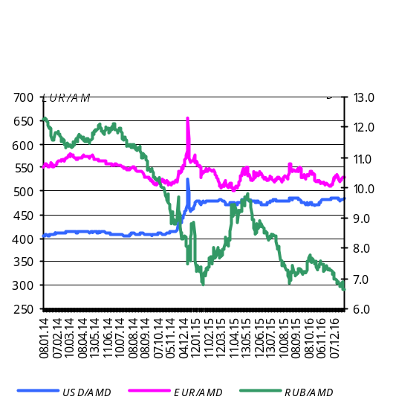 Foreign exchange market
As of end of the fourth quarter of 2015, the average market exchange rate of USD/AMD was 483.75, having depreciated by 2.08 relative to the end of the previous quarter.

The dram’s exchange rate, q/q: Q4, 2015
Currency pair | Exchange rate as of 30.09.2015 (AMD) | Exchange rate as of 31.12.2015 (AMD) | % (appreciation §+¦,  depreciation §-¦)
USD/AMD | 473.71 | 483.75 | -2.08
EUR/AMD | 531.36 | 528.69 | +0.51
RUB/AMD | 7.25 | 6.62 | +9.52

The dram’s average exchange rate, y/y: Q4, 2015
Currency pair | Average exchange rate, Q4, 2014 | Average exchange rate, Q4, 2015 | % (appreciation §+¦,  depreciation §-¦)
USD/AMD | 431.32 | 478.54 | -9.87
EUR/AMD | 538.14 | 523.87 | +2.72
RUB/AMD | 9.11 | 7.26 | +25.53

The aggregate volume of U.S. dollar/Armenian dram transactions in the foreign exchange market in the fourth quarter of 2015 amounted to USD 2.65 billion, which represents a 22.74% decrease relative to same reference period last year.
The aggregate volume of Euro/Armenian dram transactions carried out during the fourth quarter reached EUR 270.05 million, compared to EUR 304.98 million reported in the fourth quarter of 2014
The aggregate volume of Russian ruble/Armenian dram transactions in the fourth quarter of 2015 totaled RUB 20.73 billion, which represents a 51.98% increase compared to RUB 13.64 billion recorded in the fourth quarter of 2014.

3.4. Balance of payments25

In the fourth quarter of 2015 the trade balance deficit continued reducing in spite of worsening of the terms of trade26. The declining rates of remittances of individuals decelerated in comparison with the previous quarter yet it outpaced the expected rate. This was determined by continued adversities in the Russian economy in the fourth quarter. As a result, the current account deficit has increased in the fourth quarter, compared to the same reference period last year, despite a reducing trade balance deficit.
The increased in private sector’s net foreign assets notwithstanding, the current account deficit was financed primarily through foreign direct investment as well as the public sector credit funds. Under the balance of payment developments in the fourth quarter the CBA’s net foreign assets have grown sufficiently.

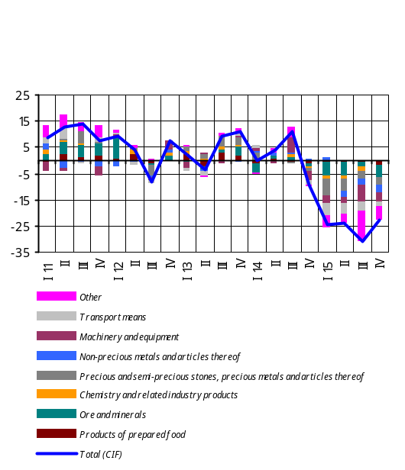3.4.1. Current account
The current account deficit-to-GDP ratio improved significantly in 2015 (around 3.0% against 7.3% in the previous year). In the fourth quarter of 2015, relative to the same reference period last year, the current account deficit-to-GDP ratio has increased by 1.3 pp, according to estimates. Relative to the fourth quarter of 2014, the dollar value of current account deficit has grown by USD 129.5 million to USD 187.3 this quarter.
28
In the period under review, the dollar value of export of goods has reduced by 11.5% y/y27, which is explained by slowing in growth rates in real export volumes and faster falling export prices. The dollar value of import of goods has decreased by 23.1% y/y due to dropped import prices and continued contraction of real volumes.
Despite worsening terms of trade, the trade balance deficit shrank in the fourth quarter by USD 180.5 million to USD 358.1 million, as a result of high growth of real exports and reduced real imports. 28
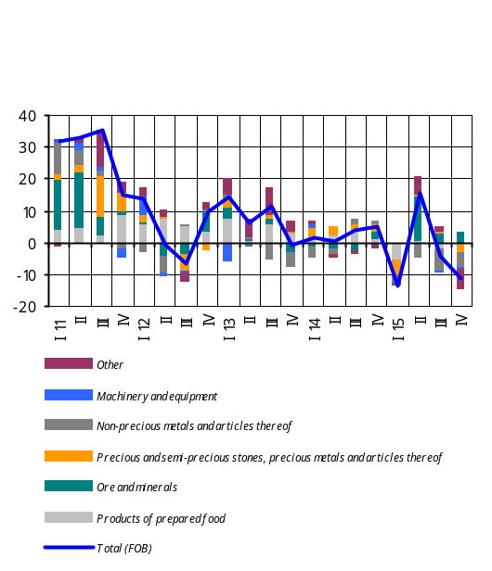 The decrease of the dollar value of export in the fourth quarter of 2015 was mainly due to the reducing dollar value of export of commodities, which primarily depend on the price developments in world commodity markets. Unlike commodities, consumer goods had a positive track of developments. A strong growth of export of the group “Textiles” is noteworthy as the latter’s dollar value has more than offset some decline in the dollar value of export of the group “Products of prepared food”. In the latter’s structure remarkable is the increase in the export of the group “Tobacco” mostly to the Middle East and the countries of the Asian region.
The decrease of the dollar value of import in the fourth quarter was due to contraction of import of all commodity groups.
The deficit of the balance of services decreased by USD 9.7 million to USD 61.7 million in the fourth quarter of 2015. This was mainly attributable to negative balance of transport services having reduced notably in relation to the fourth quarter of the previous year. As a result, for the fourth quarter of 2015, the dollar value of export and import of services is estimated to have reduced, respectively, by 5.3% and 6.5% y/y.
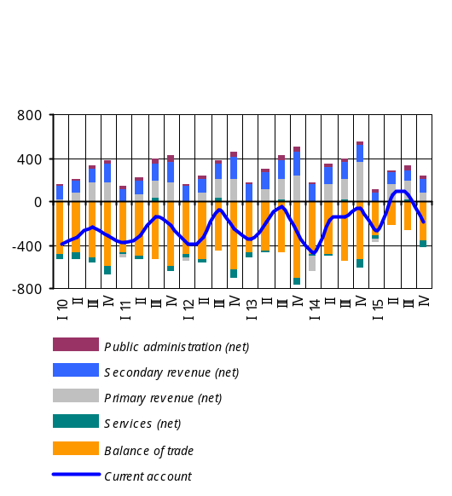In the fourth quarter of 2015, although the narrowing of the inflow of remittances of individuals29 decelerated against the previous quarter, the decline persisted because of further adversities in the Russian economy. Thus, net inflow of funds through item “Compensation of employees” posted a 26.6% y/y decrease to USD 211.1 million, which outgrew the figure of net outflow through item “Income on investment”. As a result, item “Primary income” posted net inflow of USD 79.3 million. Net inflow of private transfers has reduced by 27.0% y/y to USD 120.8 million.

3.4.2. Capital and financial account30
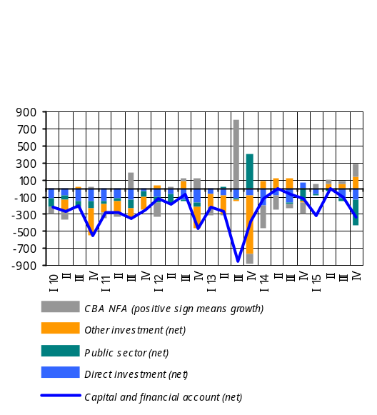 The fourth quarter of 2015 saw a large net inflow of funds through the Capital and Financial Account, amounting to USD 340.0 million, which was determined by a sizable net inflow of public credit funds, as well as net inflow of foreign direct investment, despite the increase in net foreign assets of the private sector. As a result of the balance of payment developments, net foreign assets of the CBA have grown by USD 152.7 million.
The value of capital transfers remained much the same in relation to the same reference period last year, amounting to USD 16.0 million in the fourth quarter of 2015.
Net inflow of foreign direct investment this quarter was USD 137.3 million compared to net outflow of USD 67.3 million recorded in the same reference period last year. The fourth quarter posted a net inflow of public credit amounting to USD 288.7 million (main sources: Eurasian Development Bank, World Bank and Asian Development Bank) compared with net inflow of USD 151.3 million recorded in the fourth quarter of the previous year.
Net foreign assets of the private sector grew this quarter by USD 134.7 million in contrast to a USD 11.4 million decrease reported in the same reference period last year. Specifically, net foreign assets of commercial banks have increased by USD 90.0 million and other private sector’s net foreign assets, by USD 44.7 million.

3.5. External environment

In the fourth quarter of 2015 the USA and Eurozone posted a moderate growth of their economies, while economic slowdown in Russia somewhat deteriorated in relation to the previous quarter.
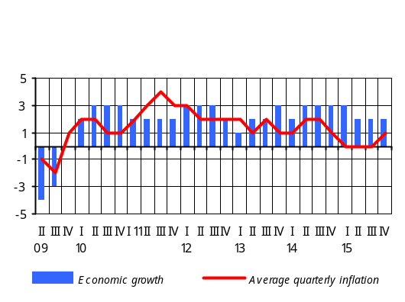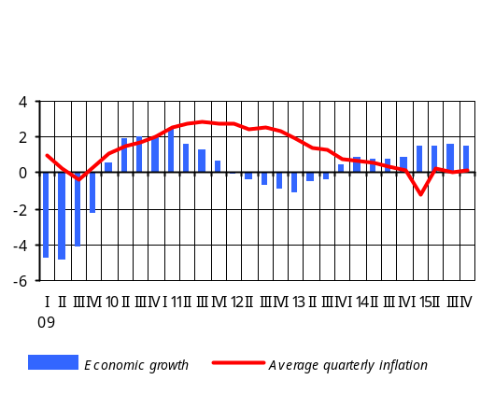 According to preliminary estimates of the U.S. Department of Commerce Bureau of Economic Analyses, the annualized economic growth in the United States was 0.7% q/q in the fourth quarter of 2015 against the previous quarter’s 1.5% growth (1.8% y/y economic growthversus 2.1% y/y growth, respectively). The contraction in net export because of appreciated exchange rate has negatively contributed to the slowing of economic growth. It is noteworthy that the slowing of economic growth in the USA was observed throughout 2015, with economic growth averaging 2.4% for the year. Average quarterly inflation in the U.S.A. in the fourth quarter of 2015 was 0.5% compared to the previous quarter’s 0.1%; at the end of the year inflation reached 0.7%. However, inflation remains well below its target mainly due to appreciate exchange rate and lower oil prices. In the fourth quarter of 2015 the US Federal Reserve System rose interest rates by 0.25 pp, and now they stand within a 0.25-0.5% range.
According to preliminary estimates provided by the Eurostat, there was 1.5% y/y economic growth in Eurozone in the fourth quarter of 2015 compared to the previous quarter’s growth of 1.6% y/y, and the economic growth for 2015 amounted to 1.5%. In Eurozone in the fourth quarter, the inflation rate quickened to 0.16% on average against the previous quarter’s figure of 0.07%, and the 12-month inflation rate reached 0.2% at the end of the year. In the fourth quarter of 2015 the European Central Bank kept the policy rate at the level of 0.05% and set the deposit facility rate at the level of -0.3% against the previous quarter’s -0.2%. The ECB carried on the purchase of asset-backed securities and covered bonds, which had started since 2014, and the purchase of sovereign bonds launched at the start of 2015.
In the currency market in the fourth quarter of 2015, Euro depreciated against the U.S. dollar by 1.5% q/q (y/y depreciation: 12.3%), with an average exchange rate reaching 1.09 for one dollar.
In Russian Federation in the fourth quarter of 2015, there was a 3.8% y/y economic decline, according to the preliminary estimates of the Economic Development Ministry (previous quarter’s figure of downturn: 4.1% y/y). The economic decline in 2015 has averaged 3.7%. With the ruble’s depreciation of about 28.9% y/y, the 12-month inflation rate in Russia amounted to 13.8% in the fourth quarter (previous quarter’s relevant figure: 14.6%), and inflation at the end of the year reached 12.9% y/y. The ruble’s q/q depreciation in the fourth quarter amounted to 4.3%. In view of continued slowing of the economy, the Central Bank of Russia kept the policy rate at the level of 11.0%.
In the fourth quarter of 2015 the price of Brent crude oil at Intercontinental Exchange fell by nearly 13.4% against the previous quarter to roughly USD 43.2 a barrel (with 42.6% y/y decrease), driven by persisting huge extraction volumes and a low global demand. The international price of oil averaged USD 49.9 a barrel in the previous quarter.

Box 7

Developments in the oil market

This is the second year in a row as the world oil market sees oil prices trending downward. Over the past one and a half years oil prices have plunged by almost 70% relative to the first half of 2014. The main factor that contributed to such a move in prices is significant increase in the world supply of oil.
Since 2009 the U.S. oil industry has been tracking a record of substantial growth in there thanks to operating new drilling equipment and developing shale oil production technology. Under such conditions, in 2014 the U.S.A. came closer with oil production volumes to Saudi Arabia and Russia – leading oil producing countries – disrupting the balance of power distribution on the global energy market and leading to imbalance between market supply and demand and, consequently, the fall in oil prices. On the other hand, a deeper decline in prices was driven by a sluggish global demand, and the slowing of the economy of China as a major importer of oil has certainly contributed to a deeper price decline. In this situation, however, instead of reducing the supply in the market, member countries of OPEC increased oil extraction volumes, in order not to lose their positions in the global oil market. This circumstance further deepened the market imbalance, bringing in additional deflationary pressures. The decline in oil prices in 2015 was driven, to some extent, by the U.S. monetary policy and the dollar’s appreciation in the context of that policy, which made the dollar-quoted oil unaffordable for oil importer countries and prompted the demand for oil products to slacken. At the beginning of 2016, sanctions imposed by the West on Iran were lifted, and that country could gain access to the international oil market, which also has contributed to the increase in market supply. Following the lifting of sanctions from January 2016, Iran is working on restoring its oil extraction and has plans for 2016 to increase production and export of oil to 1 million barrels a day (according to January data, Iran has already increased its oil supply by 2.86 million barrels a day respectively). It is noteworthy that the information about Iran having access to the oil market had, since 2015, triggered a chain of market expectations for plunging oil prices.

Judging by the estimates of marginal costs and break even points of oil producing countries and organizations, one may state that oil prices are most probably now close to their bottom line. However, a significant increase in oil prices is not expected in the coming years. All international analytical organizations have reduced their 2016 forecasts for oil prices. In particular, according to Morgan Stanley, in 2016 the price of Brent crude will average USD 49 a barrel, and in early 2017 it will reach USD 59 a barrel. According to estimates by Barclays, the average price of oil in 2016 will be USD 37 a barrel, while in 2017 it will go up to USD 43 a barrel. The Citigroup’s estimates for 2016 suggest an average oil price of USD 40 a barrel, and some USD 52 a barrel at the end of the year.
In the short-term horizon there are a number of risks to oil price developments. Specifically, possible devaluation of the U.S. dollar poses risks to the oil price increase. Uncertainties over actual volumes of Iranian oil delivered to the market as well as a likely drop in U.S. production also pose risks in terms of change in supply structure and international prices. The risks associated with oil demand and consumption boil down to a more-than-expected slowing of growth of Chinese economy.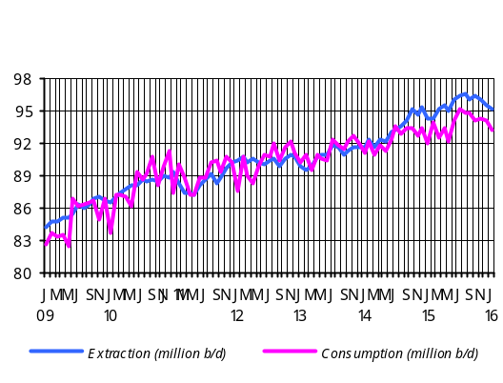

In the fourth quarter of 2015 the price of copper at the London Metal Exchange fell by 7.3% q/q (with 26.4% price decline y/y) to USD 4879 per ton on average. Weak demand in China’s economy and the dollar further being appreciated remain key factors affecting the price drop.
In the fourthquarter of 2015 export price of hard red wheat reduced by 8.9% q/q to USD 4.42 a bushel (with 26.4% decline y/y), according to the U.S. Department of Agriculture data. The price falling this quarter is explained by large worldwide production volumes and sizable inventories.
In the fourth quarter of 2015 the price index of unprocessed sugar at the New York Board-Intercontinental Exchange posted a 25.8% rise q/q (with 7.95% decline y/y). The price increase is due to the delay in harvesting in Brazil, the main producer and exporter.
In the fourth quarter of 2015, the price of rice at the Chicago Board of Trade fell by 4.2% q/q to USD 16.3 per U.S. hundredweight (45.4 kg) (with 14.8% decline y/y), amid larger production volumes.
Deflationary trends in the world’s food product and commodity markets persisted over the fourth quarter of 2015. This has been in line with the previous program’s forecast on food products while actual developments with prices of commodities deviated downside from forecasts, mainly due to a change in market judgment of production volumes.
4. Conclusion

Trends of sluggish economic activity in the economies of partners countries to Armenia persisted over 2015, so the external demand remained low. During the year deflationary patterns were observable in basic commodity and food product markets of the world. In the forecast horizon, inflationary pressures from the external environment are not likely.
In 2015 growth of economic activity amounted to 3.1% largely driven by increased output in industry and mining sectors. Under this circumstance, economic growth in 2015 is estimated in the range of 3.1-3.3% y/y.
The economic growth in 2016 is estimated to be within 1.5-2.6%, which is relatively small because of anticipated weak recovery of the economies in the partner countries in 2016, a low level of commodity prices, and highly saturated agriculture sector . It is expected that starting from 2017 the economic growth will accelerate to 3.0-4.5% at the end of the forecast horizon.
Thus, in the forecast horizon, as private demand stabilizes and the fiscal policy will be contractionary in general, the impact of aggregate demand on domestic prices will be somewhat deflationary and is expected to phase out at the end of the forecast horizon.
At the closing of the year the 12-month inflation rate was -0.1%, which was determined by persistently low domestic and external demand, a large supply agricultural of products, as well as the fact that falling prices in external sector during 2015 had already partly reflected the domestic price reduction at the end of the year.
At the end of the forecast horizon the 12-month inflation rate will stabilize around the 4% target. A low deflationary environment will be maintained over the first half of 2016 as significant inflationary pressures from the domestic economy and external sector in the short run are not expected. The inflationary effect from the change in the excise duty scheduled for May 2016 has been considered in inflation forecasts. The CBA, therefore, estimates that at the yearend the 12-month inflation rate will be at the lower bound of the confidence band; in the upcoming months, influenced by expansionary monetary policy implementation, it will expand gradually to approach and stabilize around the target in the forecast horizon.
The CBA estimates that further easing of monetary conditions in the first quarter of 2016 is relevant in such a low inflationary environment. This, coupled with loosened monetary conditions early in the year, will lead to the expanding of the aggregate demand and fulfillment of the inflation target in the forecast horizon. Moreover, gradual loosening of monetary conditions is important on the premise of relatively high inflation expectations and the risk to downside price rigidity and increasing dollarization.
Risks to inflation deviating from the projected value are estimated downside in the short run and balanced in the medium run. The downside risks are mainly attributable to the falling prices of commodities and food products in international markets and a spillover of greater impact of such price reduction on domestic prices as well as to the developments in prices of agricultural products. In the medium-term perspective, the risks deriving from domestic and external sectors are mostly persisting relative to the previous forecast. In particular, the external sector risks are related to the global economic decline and drop in international prices of commodities and food products driven by capital outflows from developing countries to the U.S.A., higher volatilities of currencies in developing countries and a sharp slowdown in Chinese economic growth. Risks deriving from the domestic sector are mostly associated with the developments in agriculture, a sector greatly depending on weather conditions, the pace at which domestic demand and private investments will recover, as well as Government-led promotion programs. If the aforementioned risks materialize, the CBA will react accordingly by maintaining the inflation target in the medium run.

See details on inflation expectations in Box 2 in this report.
The forecasts of external sector were based on the information provided from international reputable analytical, research, ratings organizations and financial institutions as well as various news agencies worldwide (including the IMF, the World Bank, The Economist, Economist Intelligence Unit, the Global Insight, the Financial Times, and so on).
See the 30% range in the Real GDP Growth (Cumulative) Projection Probability Distribution Chart.
See the 30% range in the Real GDP Growth (Cumulative) Projection Probability Distribution Chart.
See the 30% range in the Real GDP Growth (Cumulative) Projection Probability Distribution Chart.
The labor market data for 2016-2018 are the CBA projections which are based on the third quarter of 2015 data and actual October-November of 2015 figures. The growth indicators presented in this sub-section are relative to the same reference period last year, unless otherwise specified.
A gradual rise in the minimum wage in the medium run has been outlined in the Republic of Armenia’s Medium-Term Public Expenditures Program for 2016-2018.
The data of real growth of private consumption and investments for 2016-2018 are the CBA estimates. These actual figures are as of the third quarter of 2015 published by the National Statistics Service of Armenia. The real growth indicators represented in this sub-section are relative to the same reference period last year, unless otherwise specified.
The 2015 GDP is the CBA estimate.
The 2016 GDP is the CBA estimate.
The 2015 state budget indicators are preliminary and the ones presented here exclude records of off-budgetary funds.
12 The core inflation indicator is calculated and used by the CBA for a purpose of formulating and implementing a monetary policy. Specifically, this indicator is part of headline inflation that predominantly incurs the impacts of the monetary policy, and is calculated by excluding price inflation of seasonal food products (local fruits and vegetables, eggs, fish products) and regulated services from the headline inflation (see the paper “Calculation of Core Inflation by the CBA” and the table of related data at https://www.cba.am/ Storage /AM/downloads/stat_data_arm/Core%20inflation.pdf).
13 The increase in electricity tariff owes to the change of the unsubsidized fraction (for households consuming more than 250 kW/hour).
14 The price index change as of January-December 2015 is relative to the same reference period last year, unless otherwise specified.
15 Sales prices of producers of agricultural product are presented.
16 The CBA estimations of inflation expectations have been based on the Quarterly Projection Model of the CBA, under which the households’ inflation expectations are shaped through factors that affect both previous and future inflation period.
17 The indicators of y/y real growth of value added in sectors of the economy for January-December 2015 are the CBA forecasts, whereas the indicators of sub-sectors represent y/y growth rates in output volumes for January-December 2015, unless otherwise specified.
18 See the 30% range in Real GDP Growth (Cumulative) Projection Probability Distribution Chart.
19 The private spending, private consumption and private investment indicators for the fourth quarter of 2015 are the CBA estimates which are based on the third quarter of 2015 data. The growth estimates provided in this sub-section are relative to the same reference period last year, unless otherwise specified.
20 Real export and import growth indicators are the CBA estimates.
21 The labor market data for the fourth quarter of 2015 are the CBA estimates which are based on the third quarter of 2015 data and actual October-November 2015 figures. The growth indicators provided in this sub-section are relative to the same reference period last year, unless otherwise specified.
22 The review of the fiscal sector was done using the preliminary actual consolidated budget indicators prepared on the basis of the preliminary actual indicators of the fourth quarter of 2015 (PIU funds included), excluding off-budgetary funds. The impact of revenues was calculated in respect of the nominal GDP indicator while the impact of expenditures, in respect of an estimated economic potential.
23 Records of off-budgetary funds are excluded.
24 The fourth quarter 2015 indicator of the real exchange rate is the CBA estimate.
25 The fourth quarter 2015 indicators are the CBA’s forecasts and estimates.
26 The y/y decrement of dollar prices of export has notably outpaced the y/y falling of dollar prices of import, according to estimates.
27 The export and import indicators are presented on a basis of the balance of payments, by the use of credit and debit, respectively.
28 The export and import indicators by commodity group are presented by prices FOB and CIF, respectively.
29 In the fourth quarter of 2015 net inflow of non-commercial remittances of individuals via the banking system shrank by 28.5% y/y.
30 The fourth quarter 2015 capital and financial account indicators are the CBA’s forecasts and estimates.

